Envirothon
Envirothon is a state wide competition between high school students. Our school has participated in the county wide competition but hasn’t advanced to the state. Our school used to participate 15 -20 years ago but then stopped for some time. Then 2013-2014 we were able to get a small team together. We have competed the last 2 years and then will be competing again in 2016. The groups have consisted of 5-7 students, some new and some repeating members. There is a training day and then the competition day held at Kings Landing. Winners then advance to the state competition. NHS won 5th place in 2014 and 4th place in 2015. We hope to keep moving up.
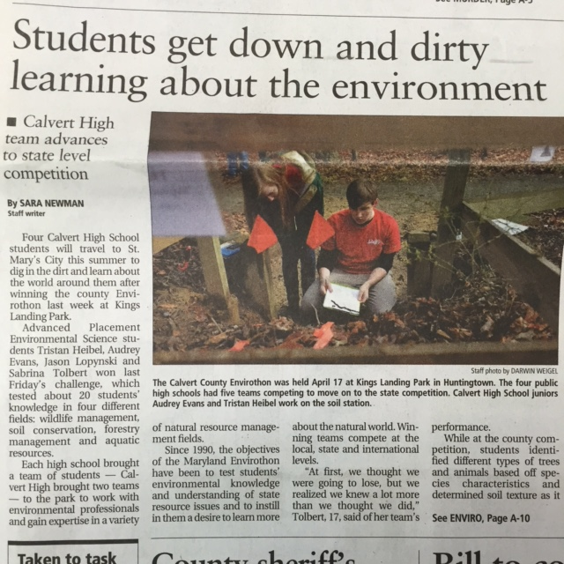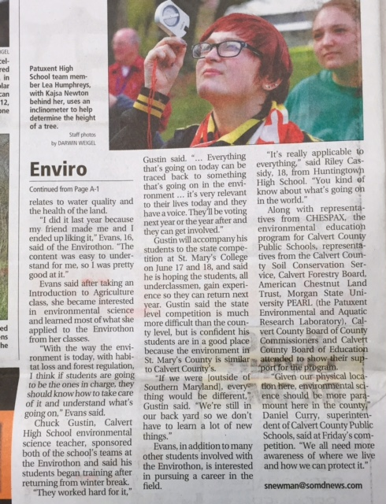
Picture taken of the Calvert Recorder newpaper on April 24, 2015.

