Fall 2014/spring 2015/Fall 2015/Spring 2016
Walton Beach nature preserve living shoreline habitat restoration

Biology, Environmental and Lorax members worked over the past 2014-2015 and 2015-2016 school years to help Environmental Concern restore the shoreline on Walton’s Beach to a living shoreline. The beach has been eroding away for many years now. There was a big sea grass planting on Tues. September 8, 2015 which many students were involved in.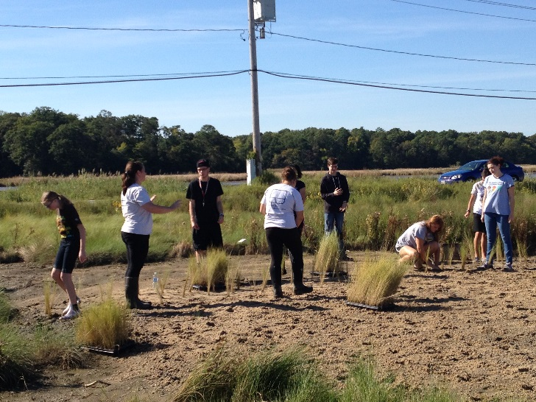 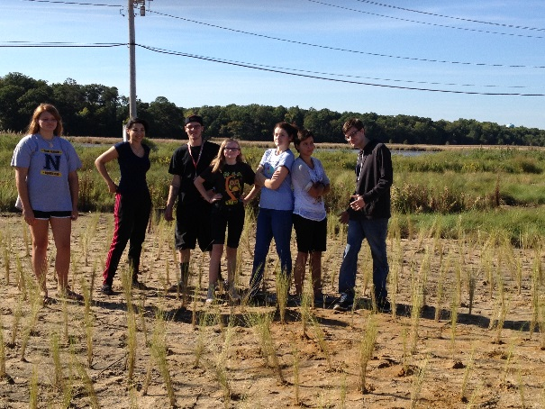

Members of Northern High School planting sea grass Sept. 8, 2015.

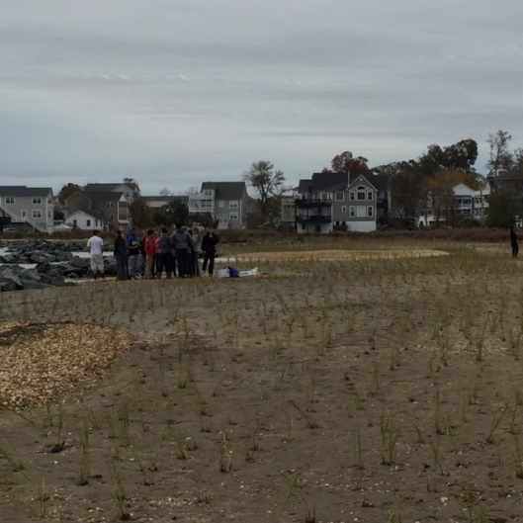
Nov. 2, 2015 after planting picture. Some of the grasses were taken out by the past hurricane. Some replanting needs to be done.

