Objective 3: Community Partnerships, Awards, and Special Recognition
3.1 Community Partnerships
With: Sunderland Elementary School and Calvert County Soil Conservation District which provides the Calvert Environmental Trust for Youth grant.
Annually since 2003, approximately 20 NHS students and 80-100 SES children yearly.
Members of the LORAX club have partnered with Sunderland Elementary School in Calvert County to hold an outdoor education day. Approximately 100 third-graders and five teachers from SES visit NHS each spring. The event - usually held on Earth Day – is paid for with a grant from Calvert Environmental Trust for Youth. During the day, outdoor lessons in stream health, the importance of forests, the fun in recycling, and in the importance of biodiversity are taught by high school students. The LORAX club has run this event annually for twelve years.

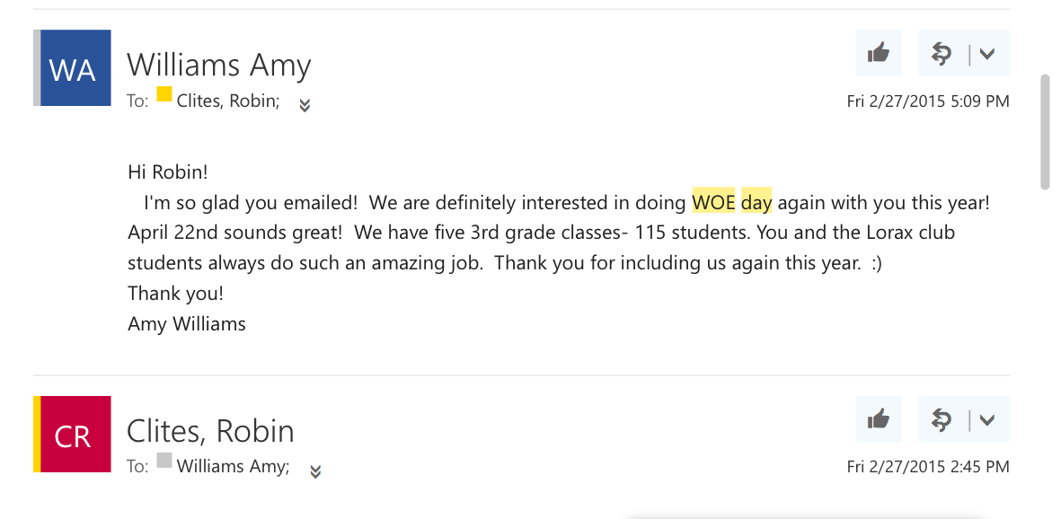
Email correspondence between SES teacher Amy Williams and Lorax sponsor setting up the WOE Day event for Spring 2015. February 27, 2015.

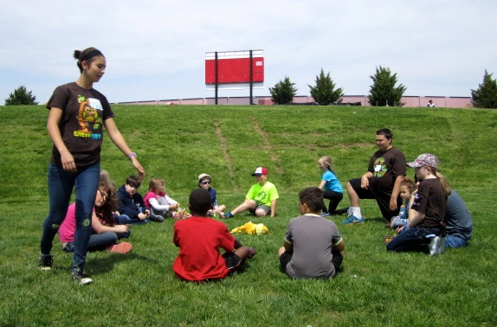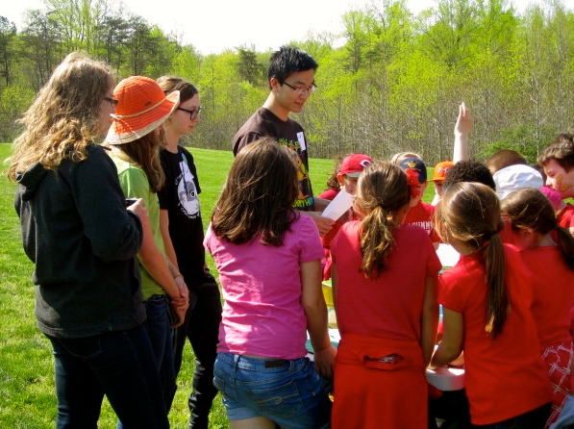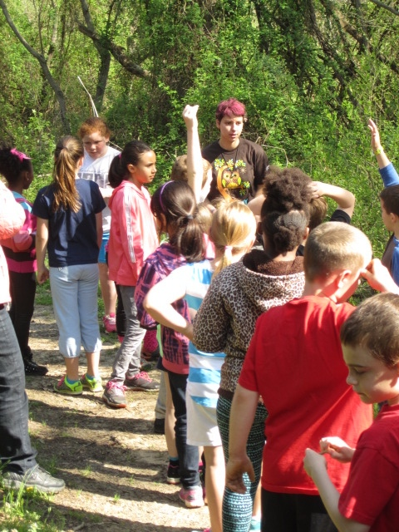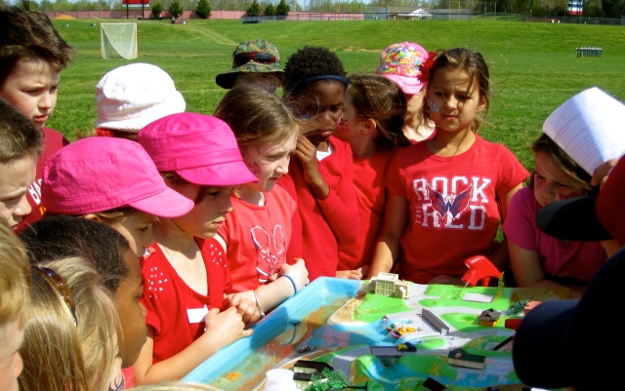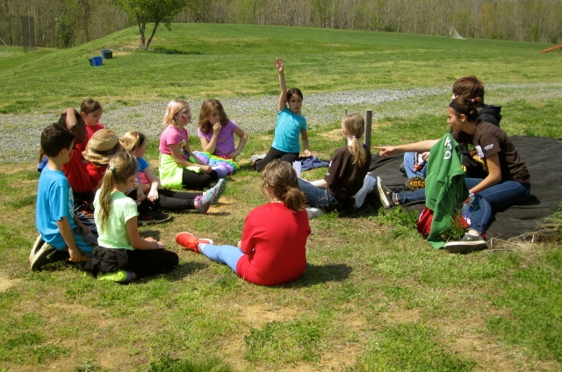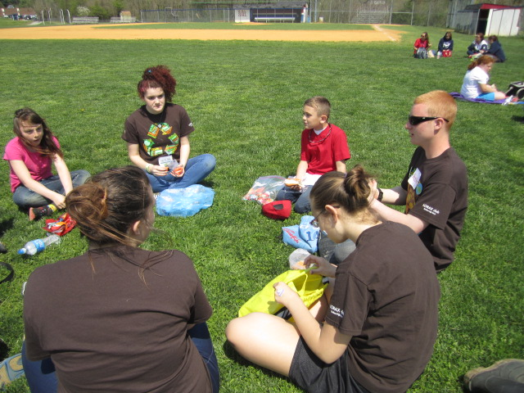
Snapshots of NHS students and SES students on WOE Day 2015.
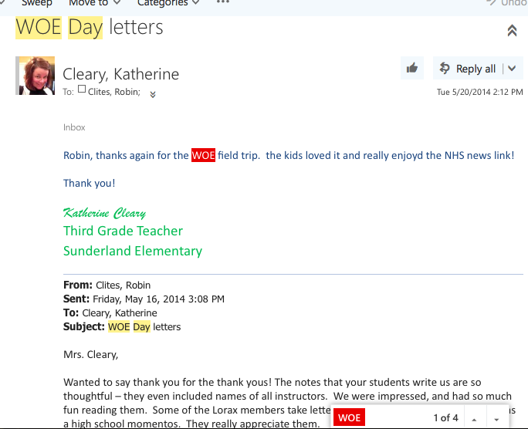
Screenshot of correspondence between LORAX club sponsor and SES teacher Katherine Cleary after the spring 2014 WOE Day event.

