Objective 2: Student Driven Sustainability Practices

2.3 Solid Waste Reduction

Paper, cardboard, newpapers, aluminum cans, glass and plastic bottles are collected in all classrooms and open areas of Northern High School. The building services staff takes care of materials collected in the common spaces, and the Lorax club sees that classroom bins are emptied into the outside dumpster on a regular basis.

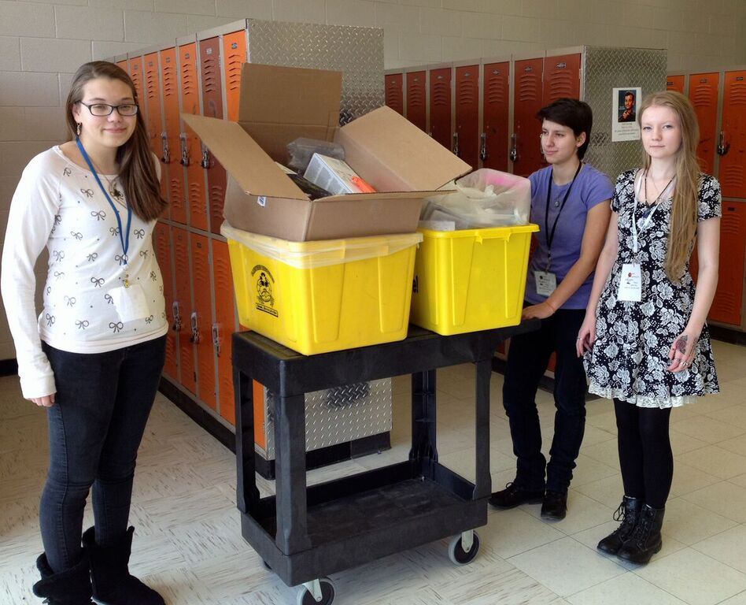

Lorax members caught in the middle of a recycling run. Groups like this collect the classroom and office recyclables almost every day during lunch shifts.

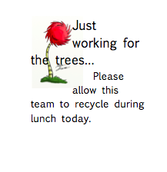
Hall pass that Lorax students use when recycling during lunch shifts.

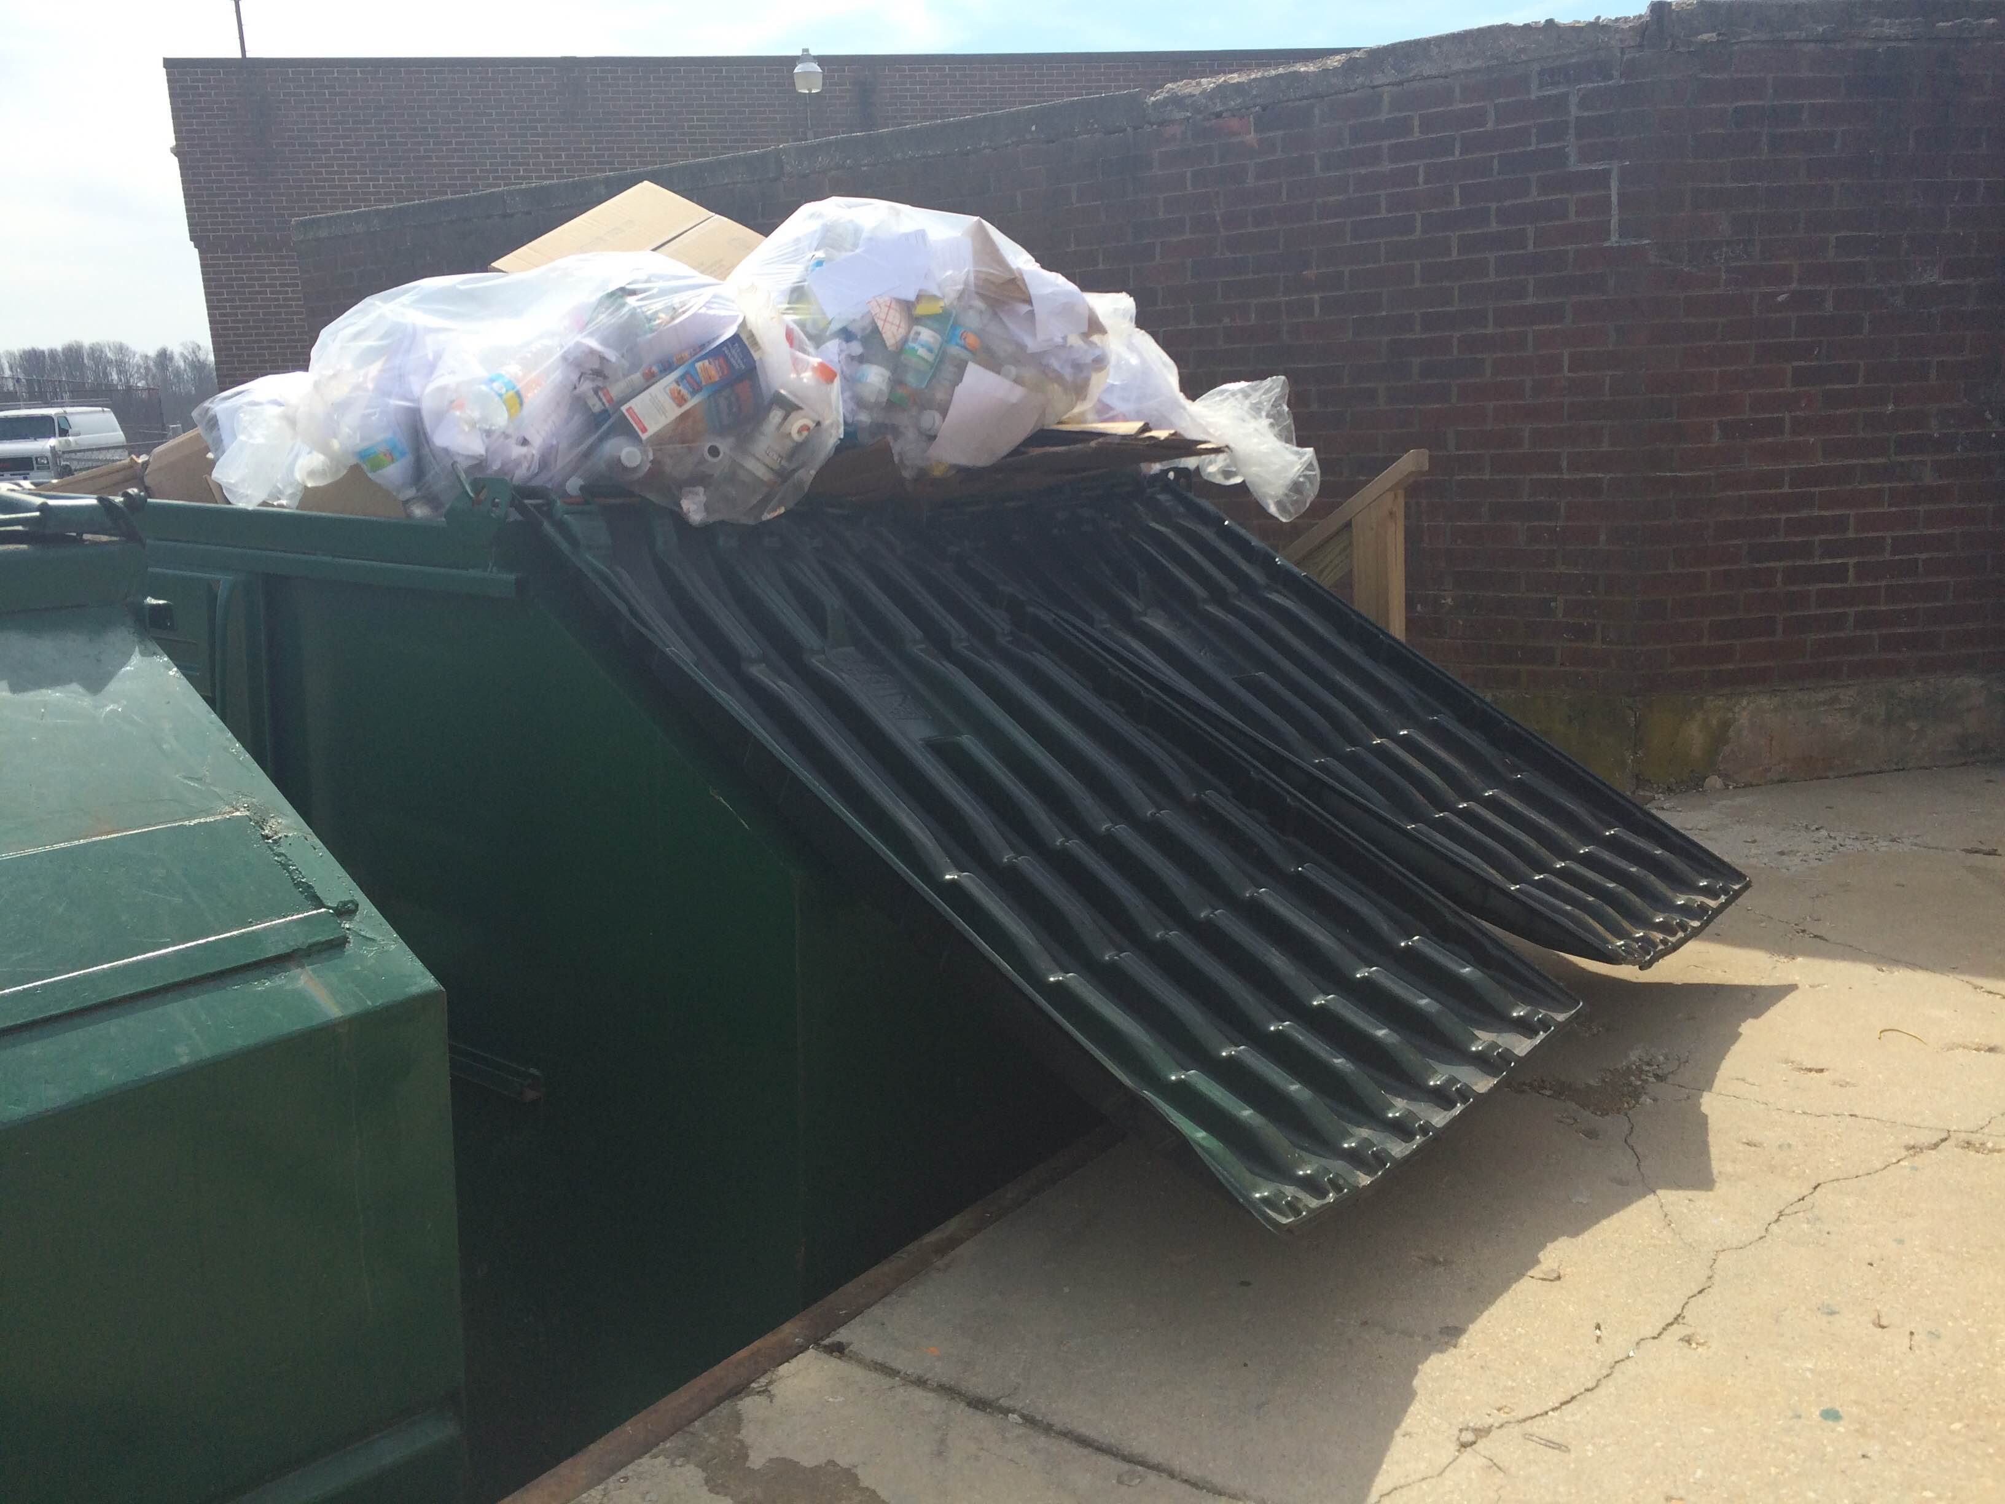
Dumpster at NHS on a typical Wednesday just before pickup time.

