2.3 Solid Waste Reduction

Clothing drives to reuse and repurpose discarded clothing, conserving resources.

Most school years; specifically Fall 2014, Fall 2015, and Winter 2016.

A popular project at Northern High School is to collect gently used items like coats, jeans, and general clothing to donate to a local charity like Project Echo homeless shelter or the Catholic Charities organization. National Honor Society, the Fashion Club and he Better World club all held clothing drives in the past two school years.

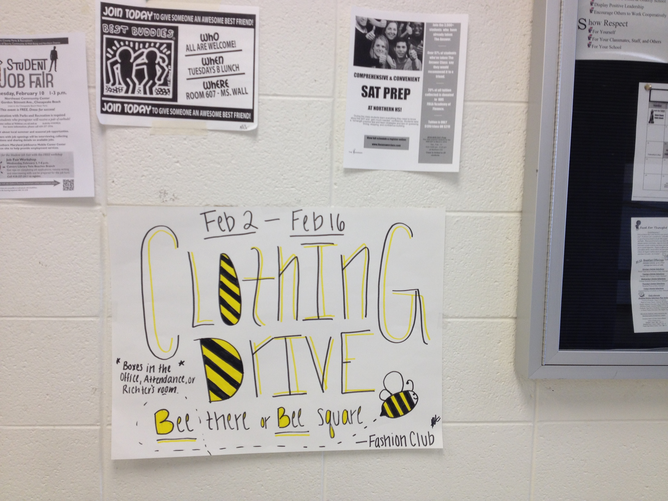

Sign announcing clothing drive sponsored by the Fashion Club at NHS. February 2016.

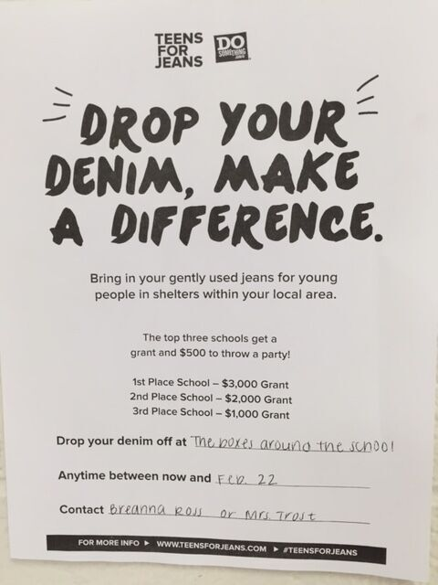

Poster on the wall soliciting donations of gently used jeans, February 2016.

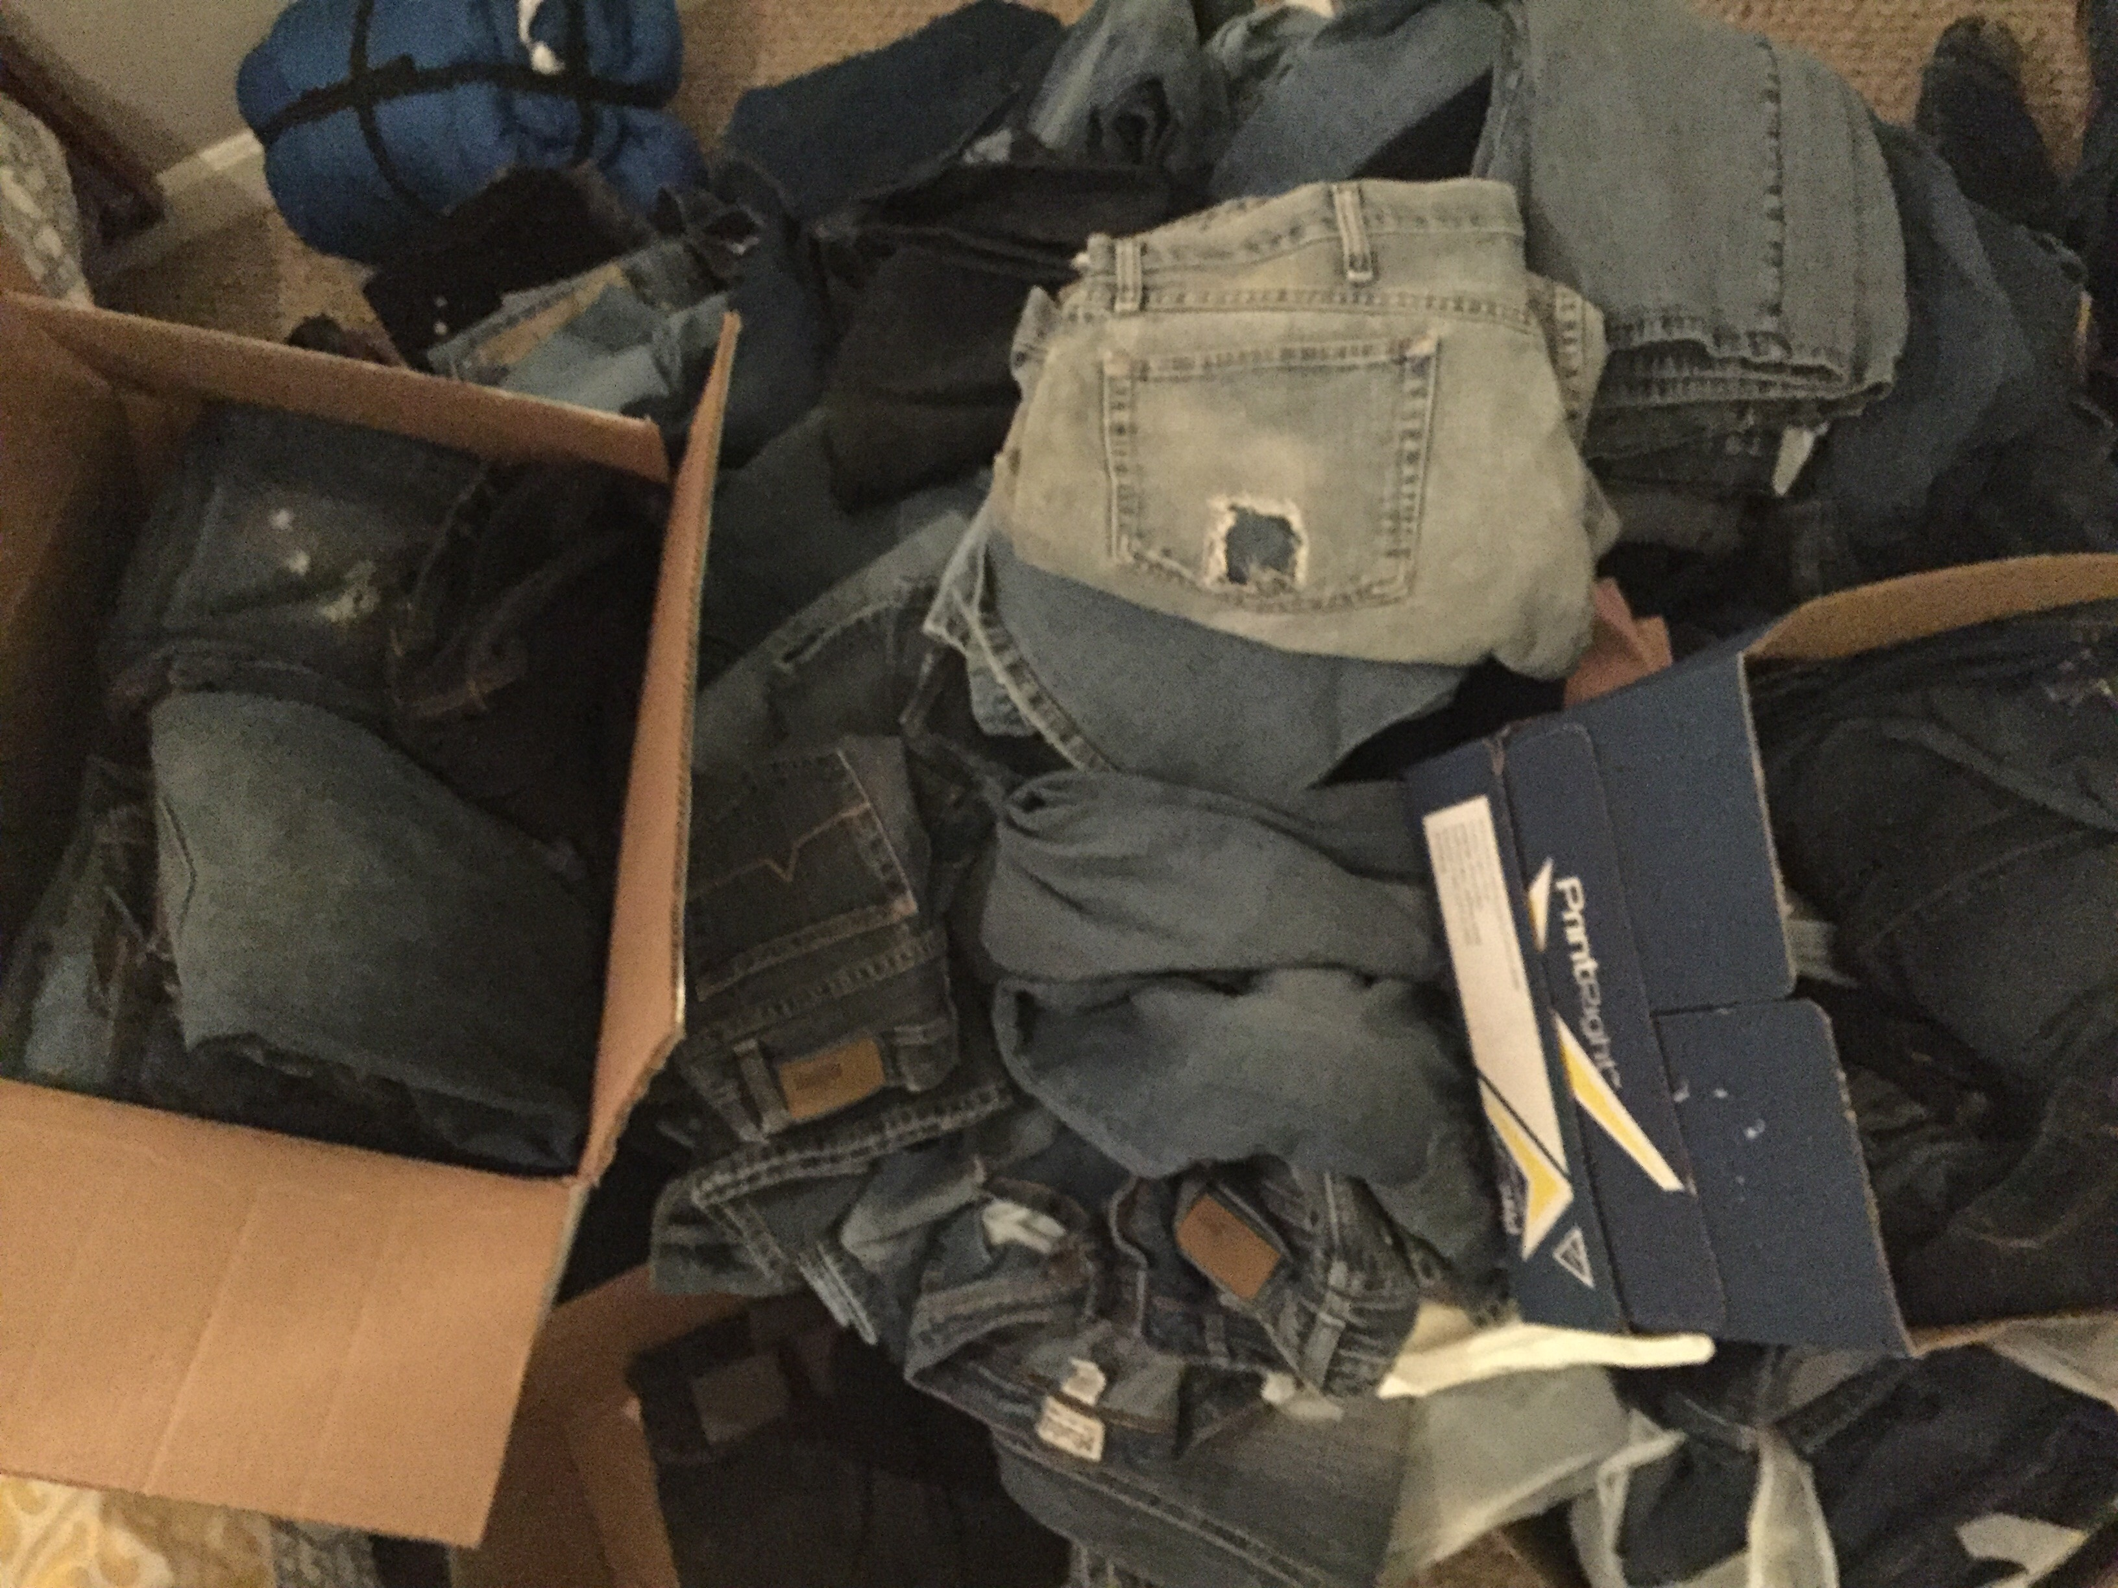
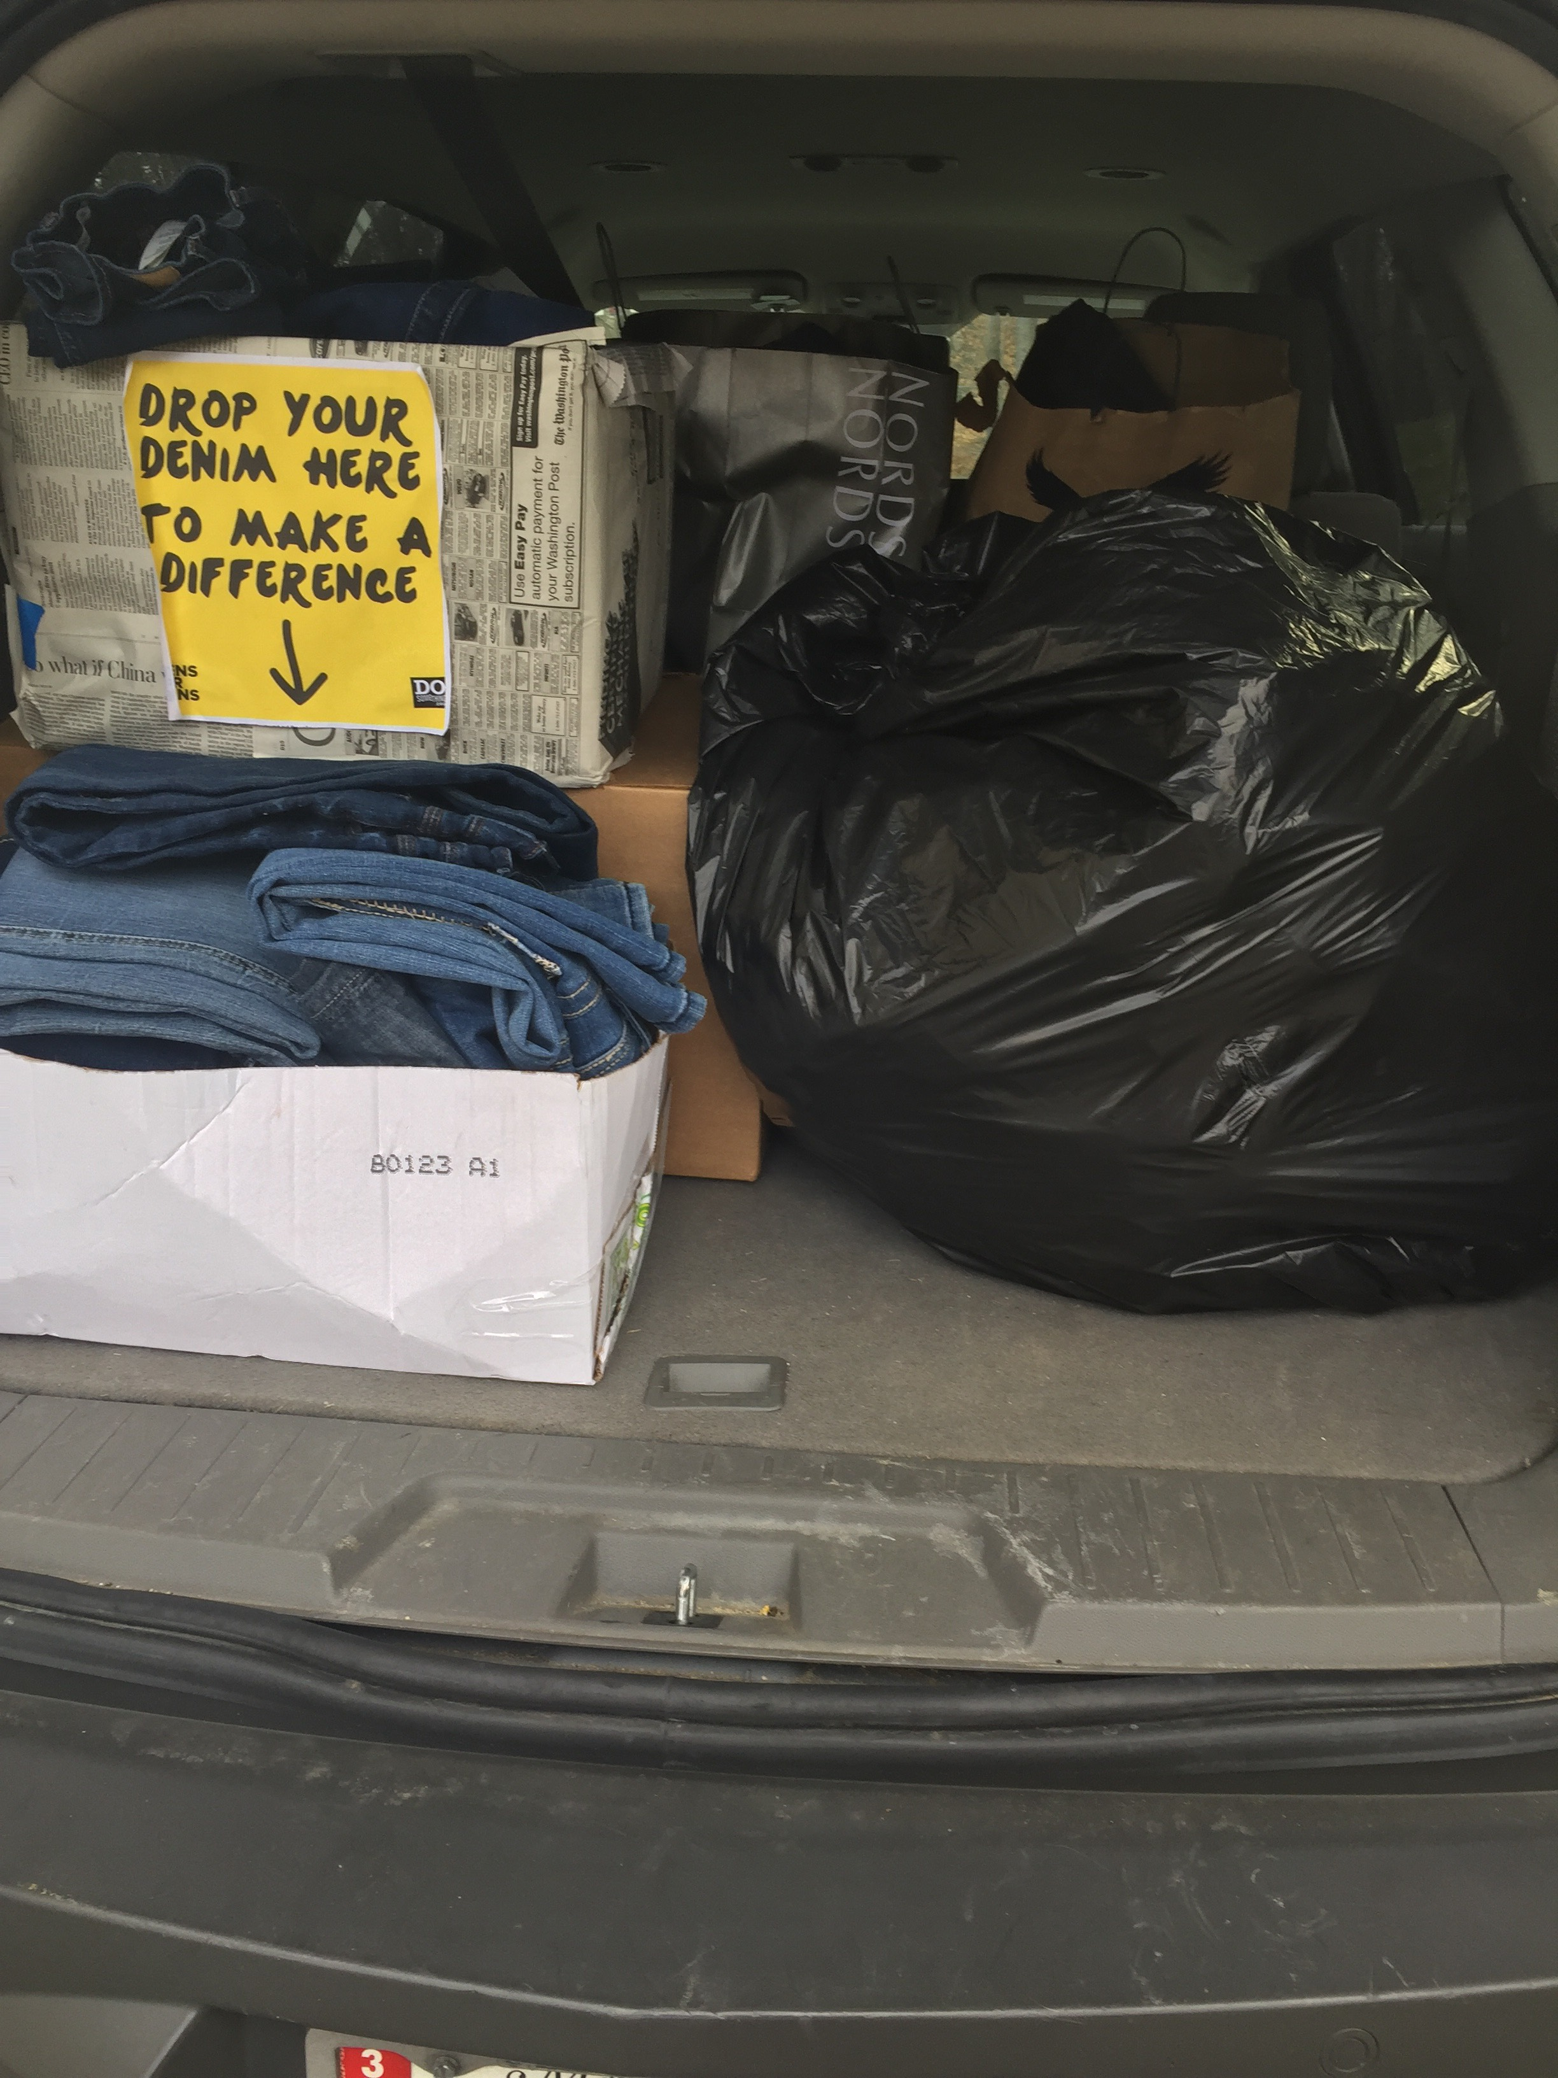
A good collection of denim for the Teens for Jeans program.

