Objective 2: Student Driven Sustainability Practices

2.3 Solid Waste Reduction

Electronic waste and ink jet cartridges are also collected and recycled at NHS. About twice a year, boxes of such items are sent to Ecophones Recycling company. http://www.recyclingfundraiser.com

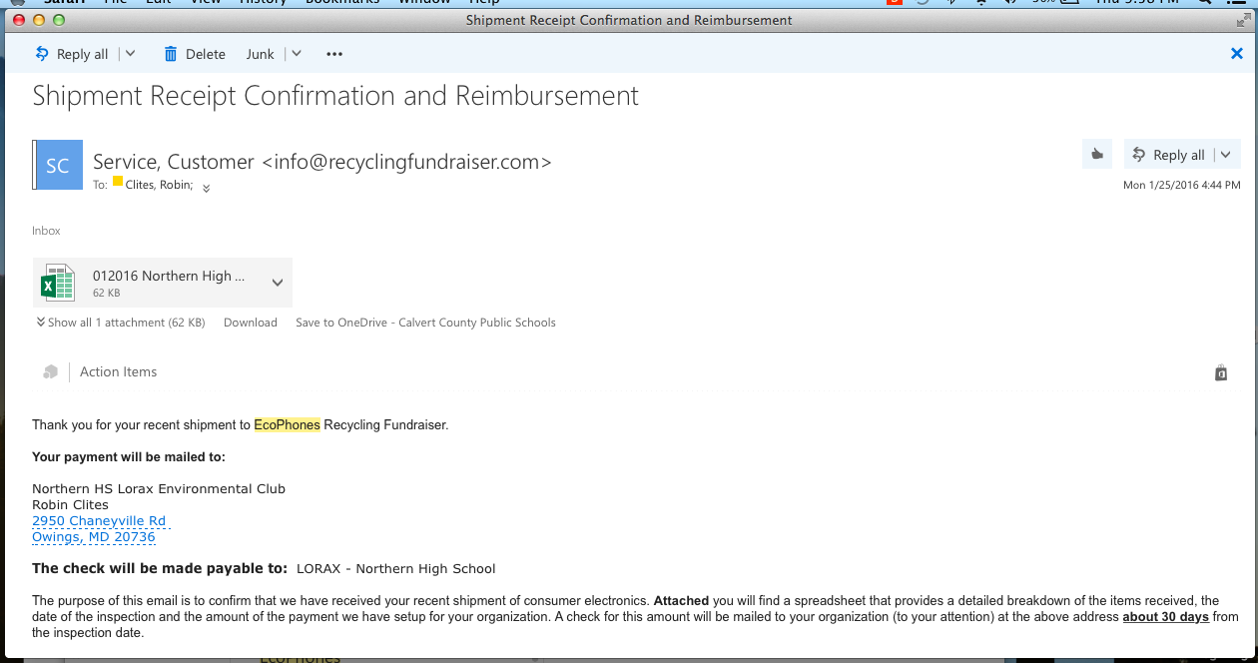

Screenshot of digital receipt for recycling e-waste with Ecophones company.
January 25, 2016.

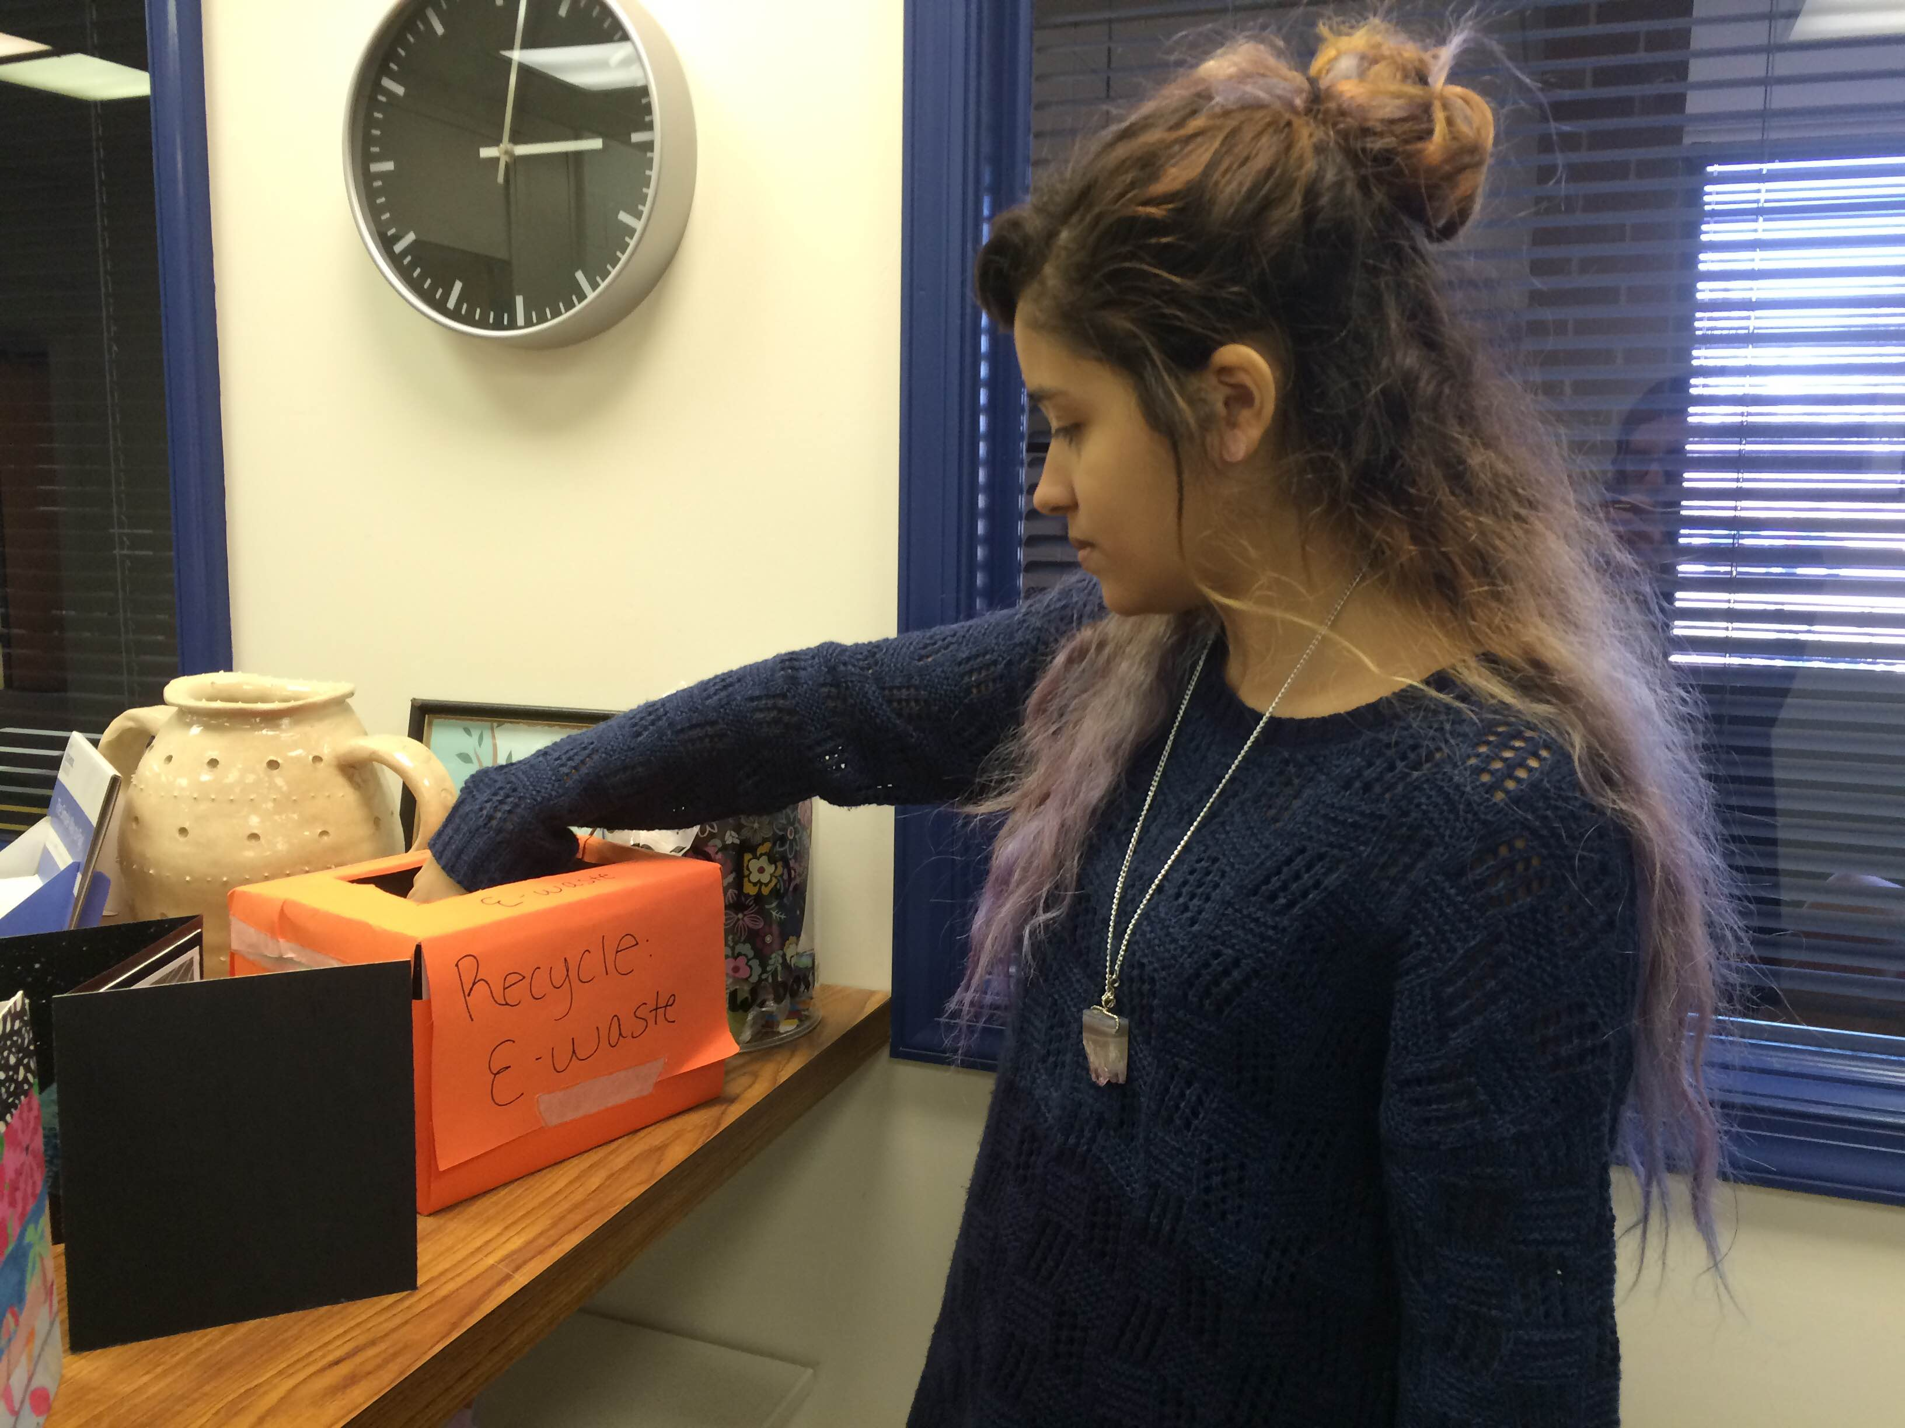

Junior Celine Gautrois retrieving e-waste from collection box in main office.

