Objective 2: Student Driven Sustainability Practices
2.2 Energy Conservation

While brainstorming ideas to reduce energy consumption in our building, Lorax club members proposed making reminders to turn off lights in classrooms when not in use. It was thought that a bright green light switch border with a clever statement might serve this purpose well. Students stayed after school and used lunch hour time to produce these borders and attach them around nearly all light switches in classrooms and offices.

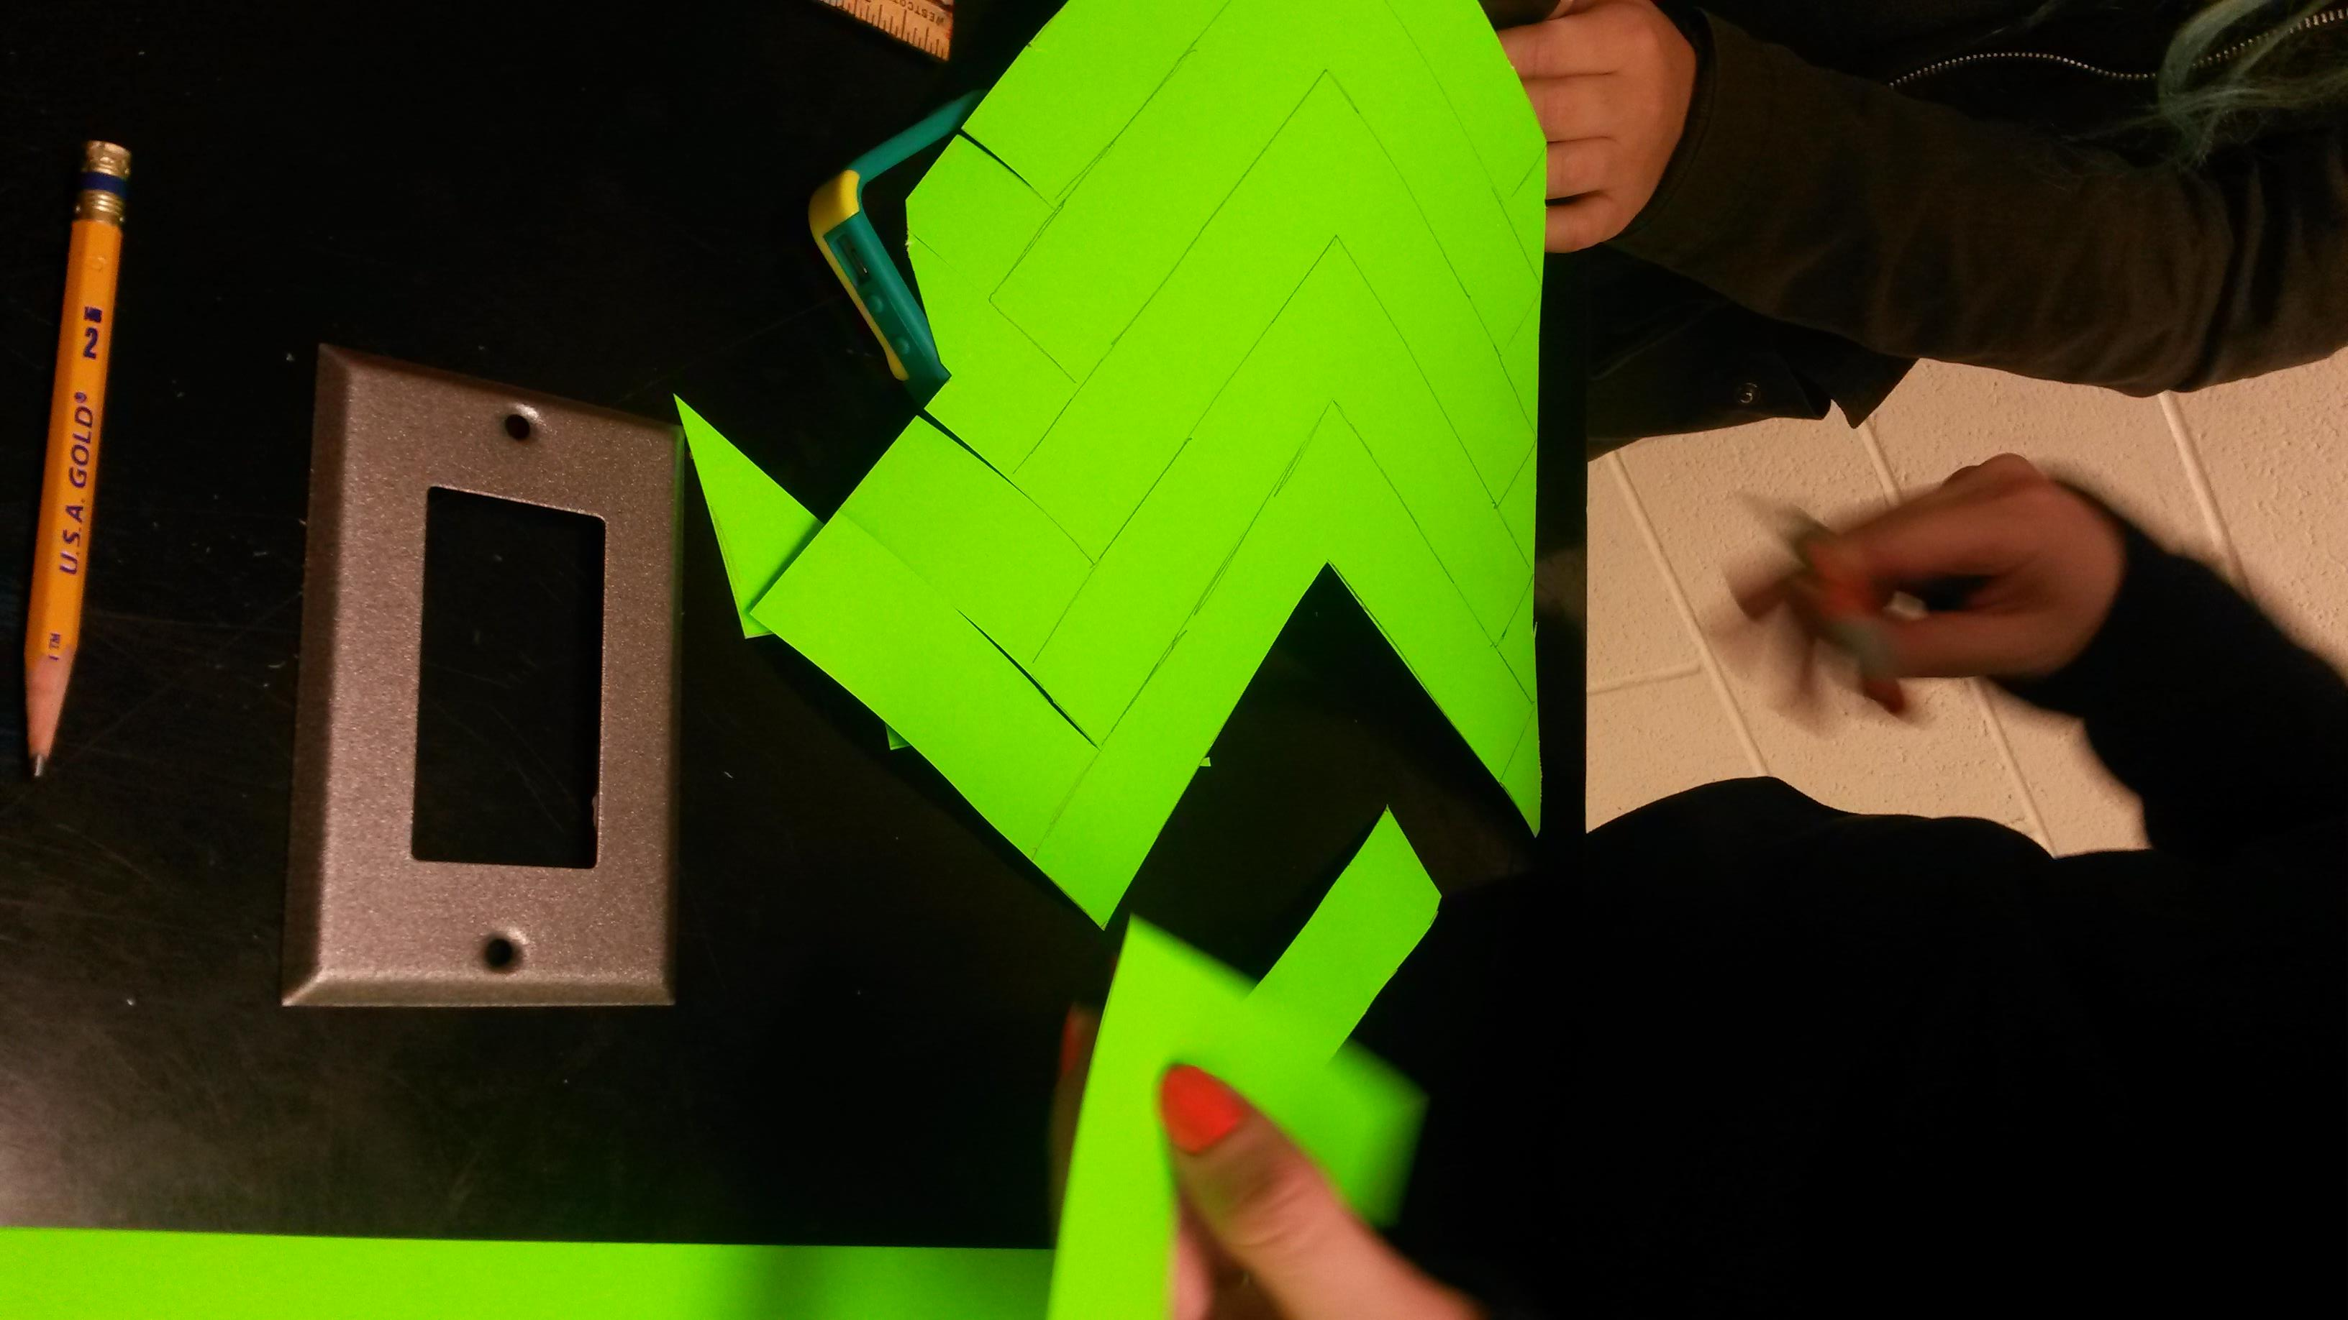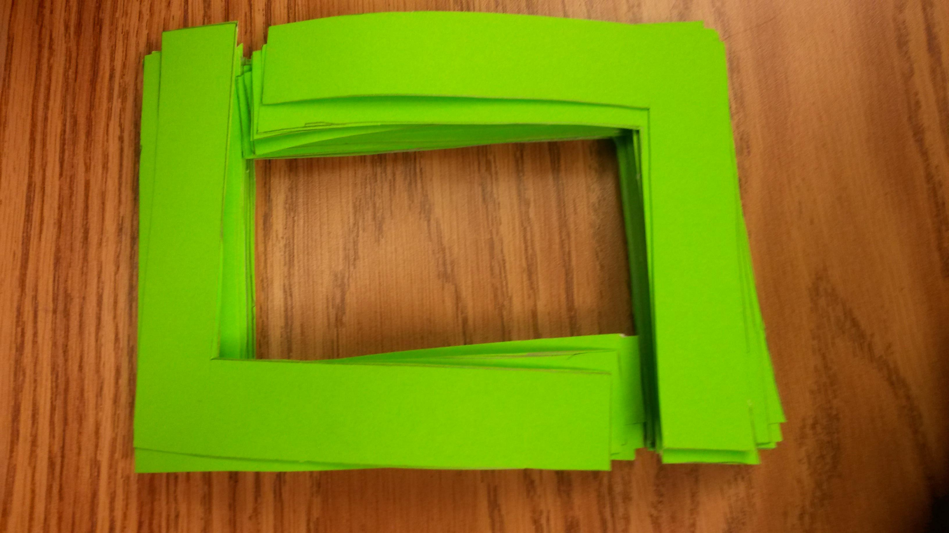
Making the light switch reminders. January, 2016

Add: The light switch reminders in action. (need photo) February, 2016

