Objective 2: Student Driven Sustainability Practices
2.1 Water Conservation/Pollution Prevention

Bayfront Park Clean Up

Bayfront Park is a natural sandy beach just south of the town of Chesapeake Beach. Many residents use it for recreation during the hot summer days. This well-used park can collect a good bit of trash by season’s end. As a pollution prevention measure, students initiated contact with Chesapeake Beach town councilman Pat Mahoney to arrange a cleanup. They made announcements over the school PA system to solicit help and met early on the morning of October 24, 2015 with rakes and trash bags, prepared for work.

The same group hopes to participate in a clean up at the park this spring and to continue the fall event each year as well.

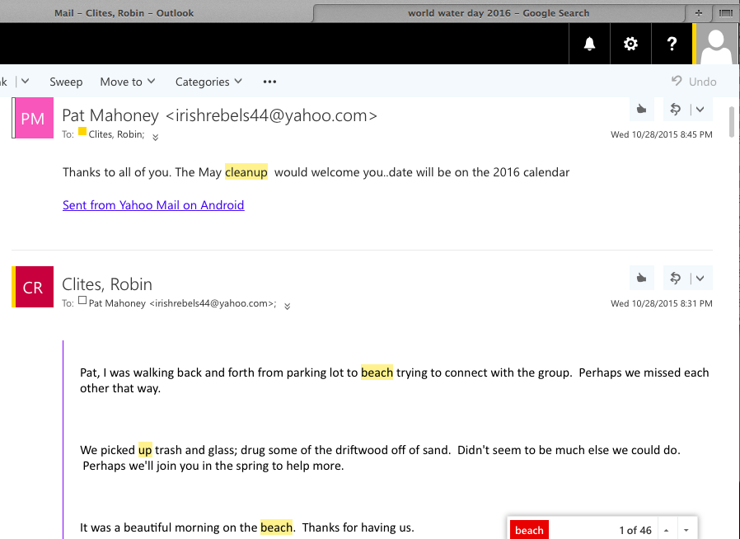

Email correspondance between Lorax club sponsor and councilman Pat Mahoney just after beach clean-up day.
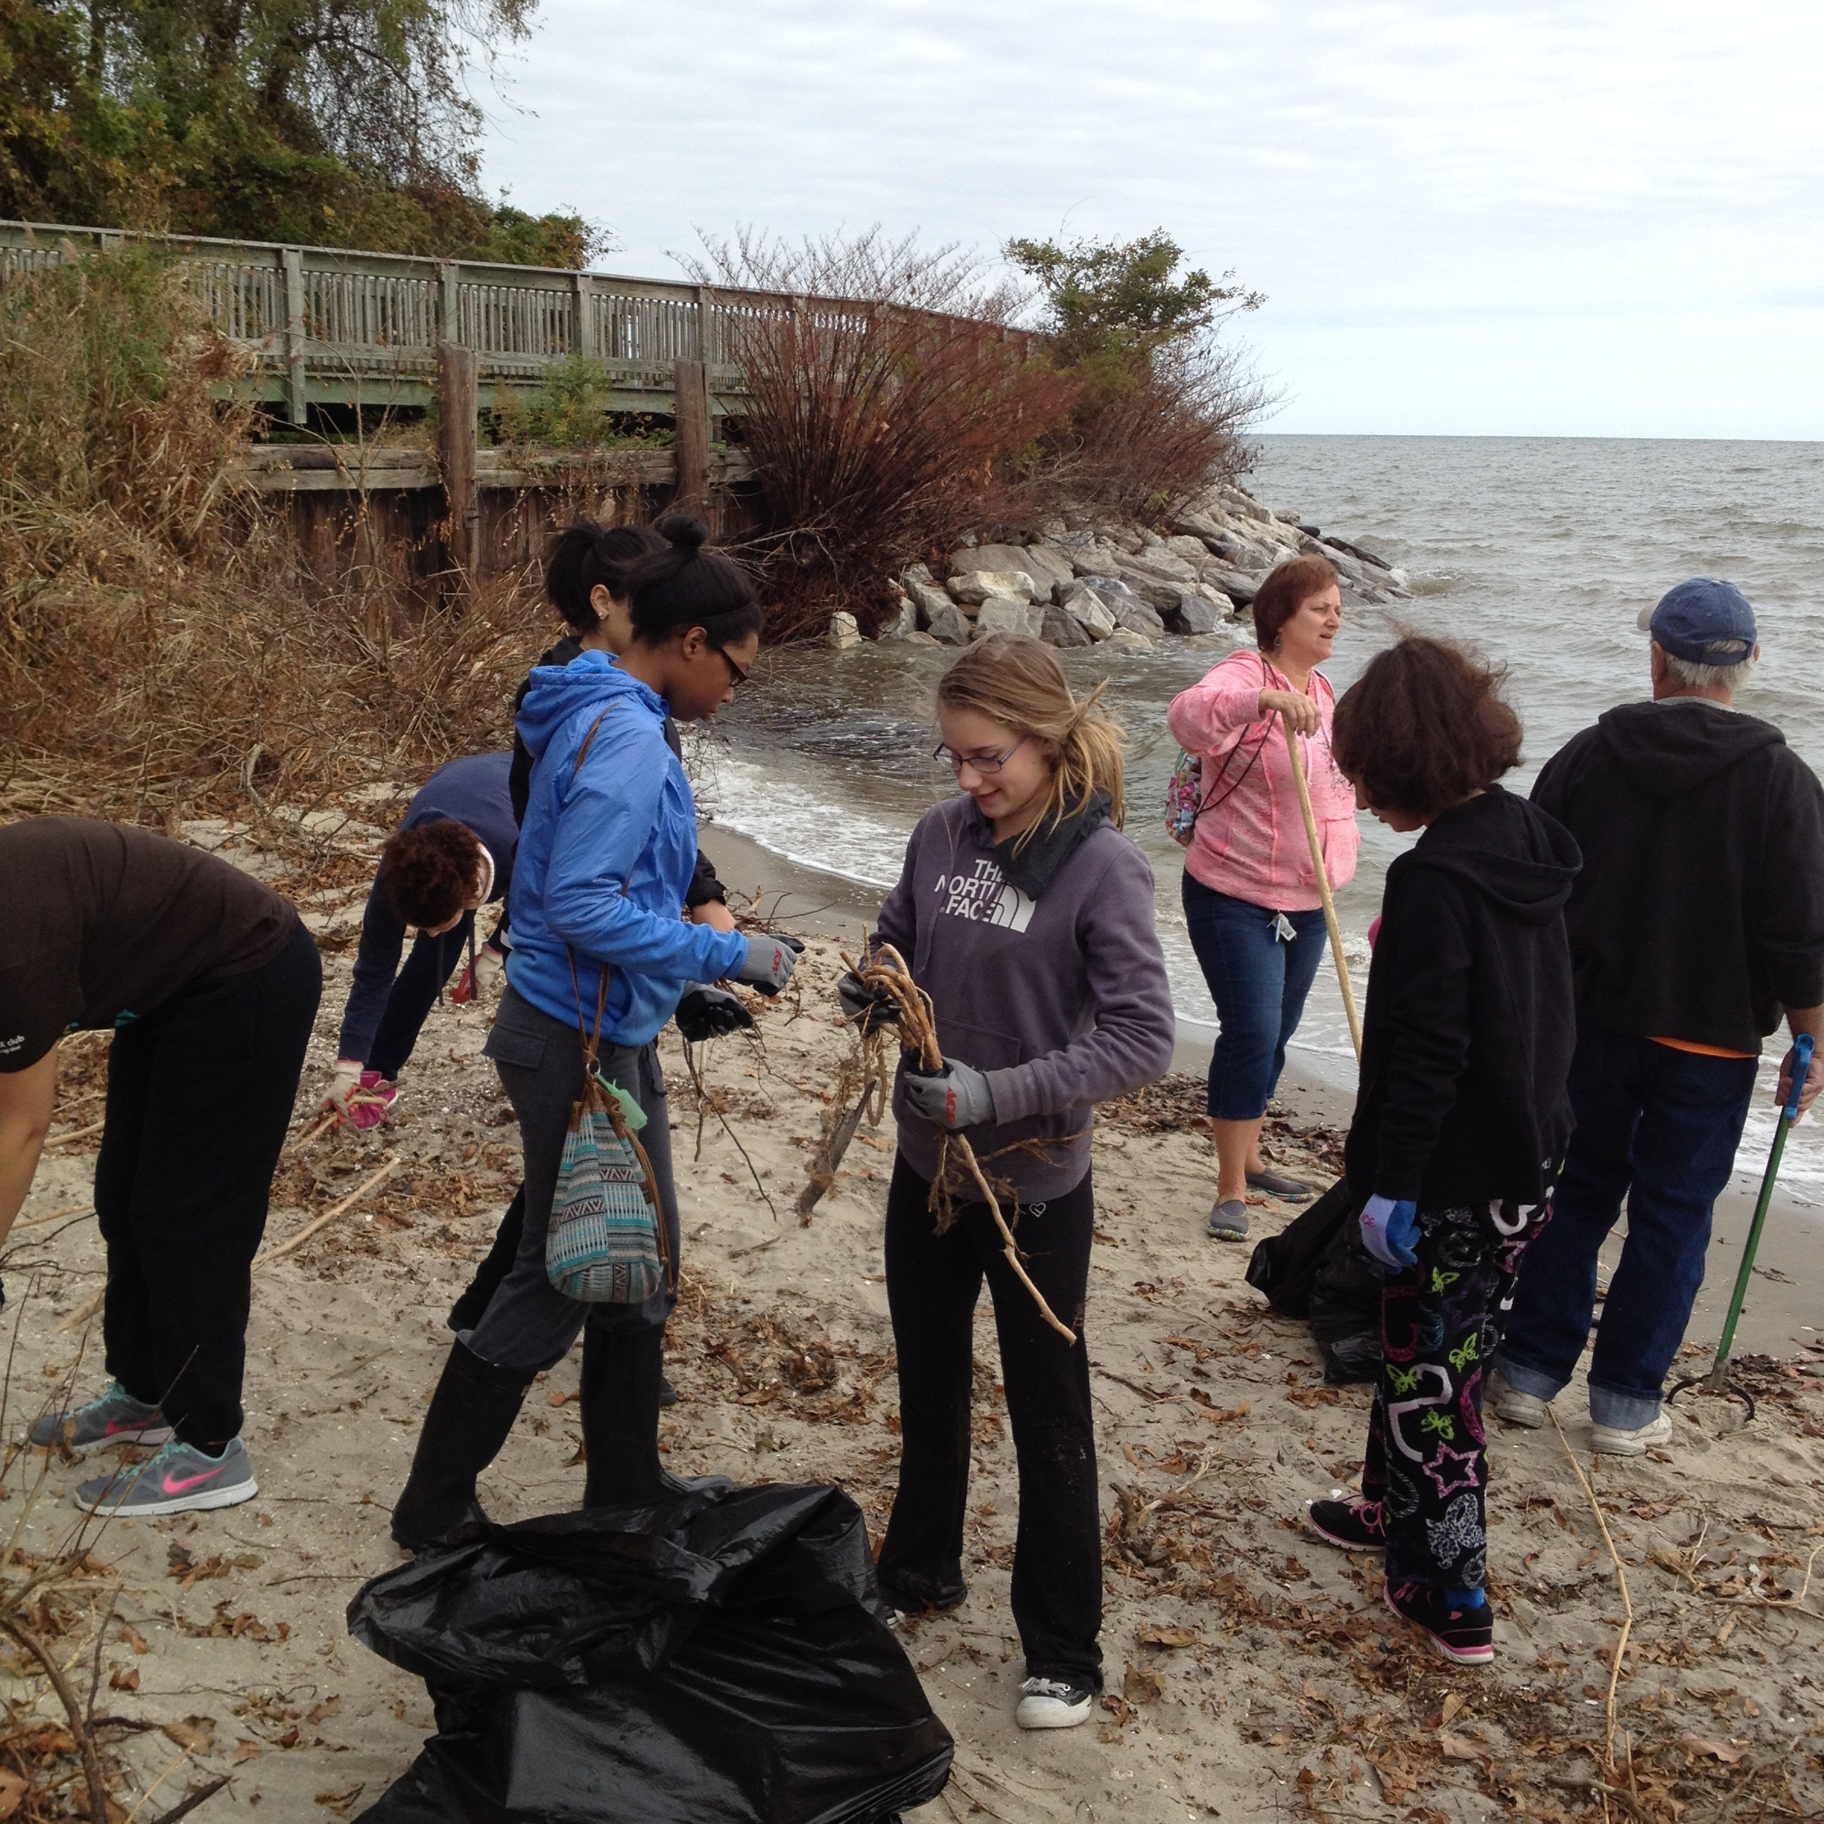 Students collecting trash at Bayside Park, October 24, 2015.
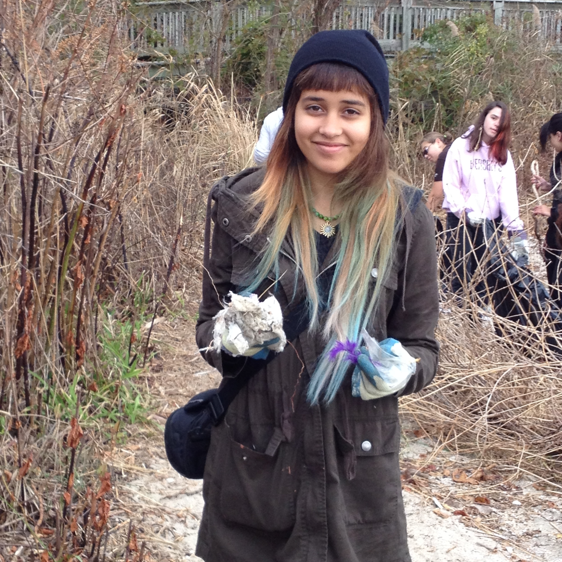Sophomore Celine Gautrois at the beach clean-up, October 24, 2015. 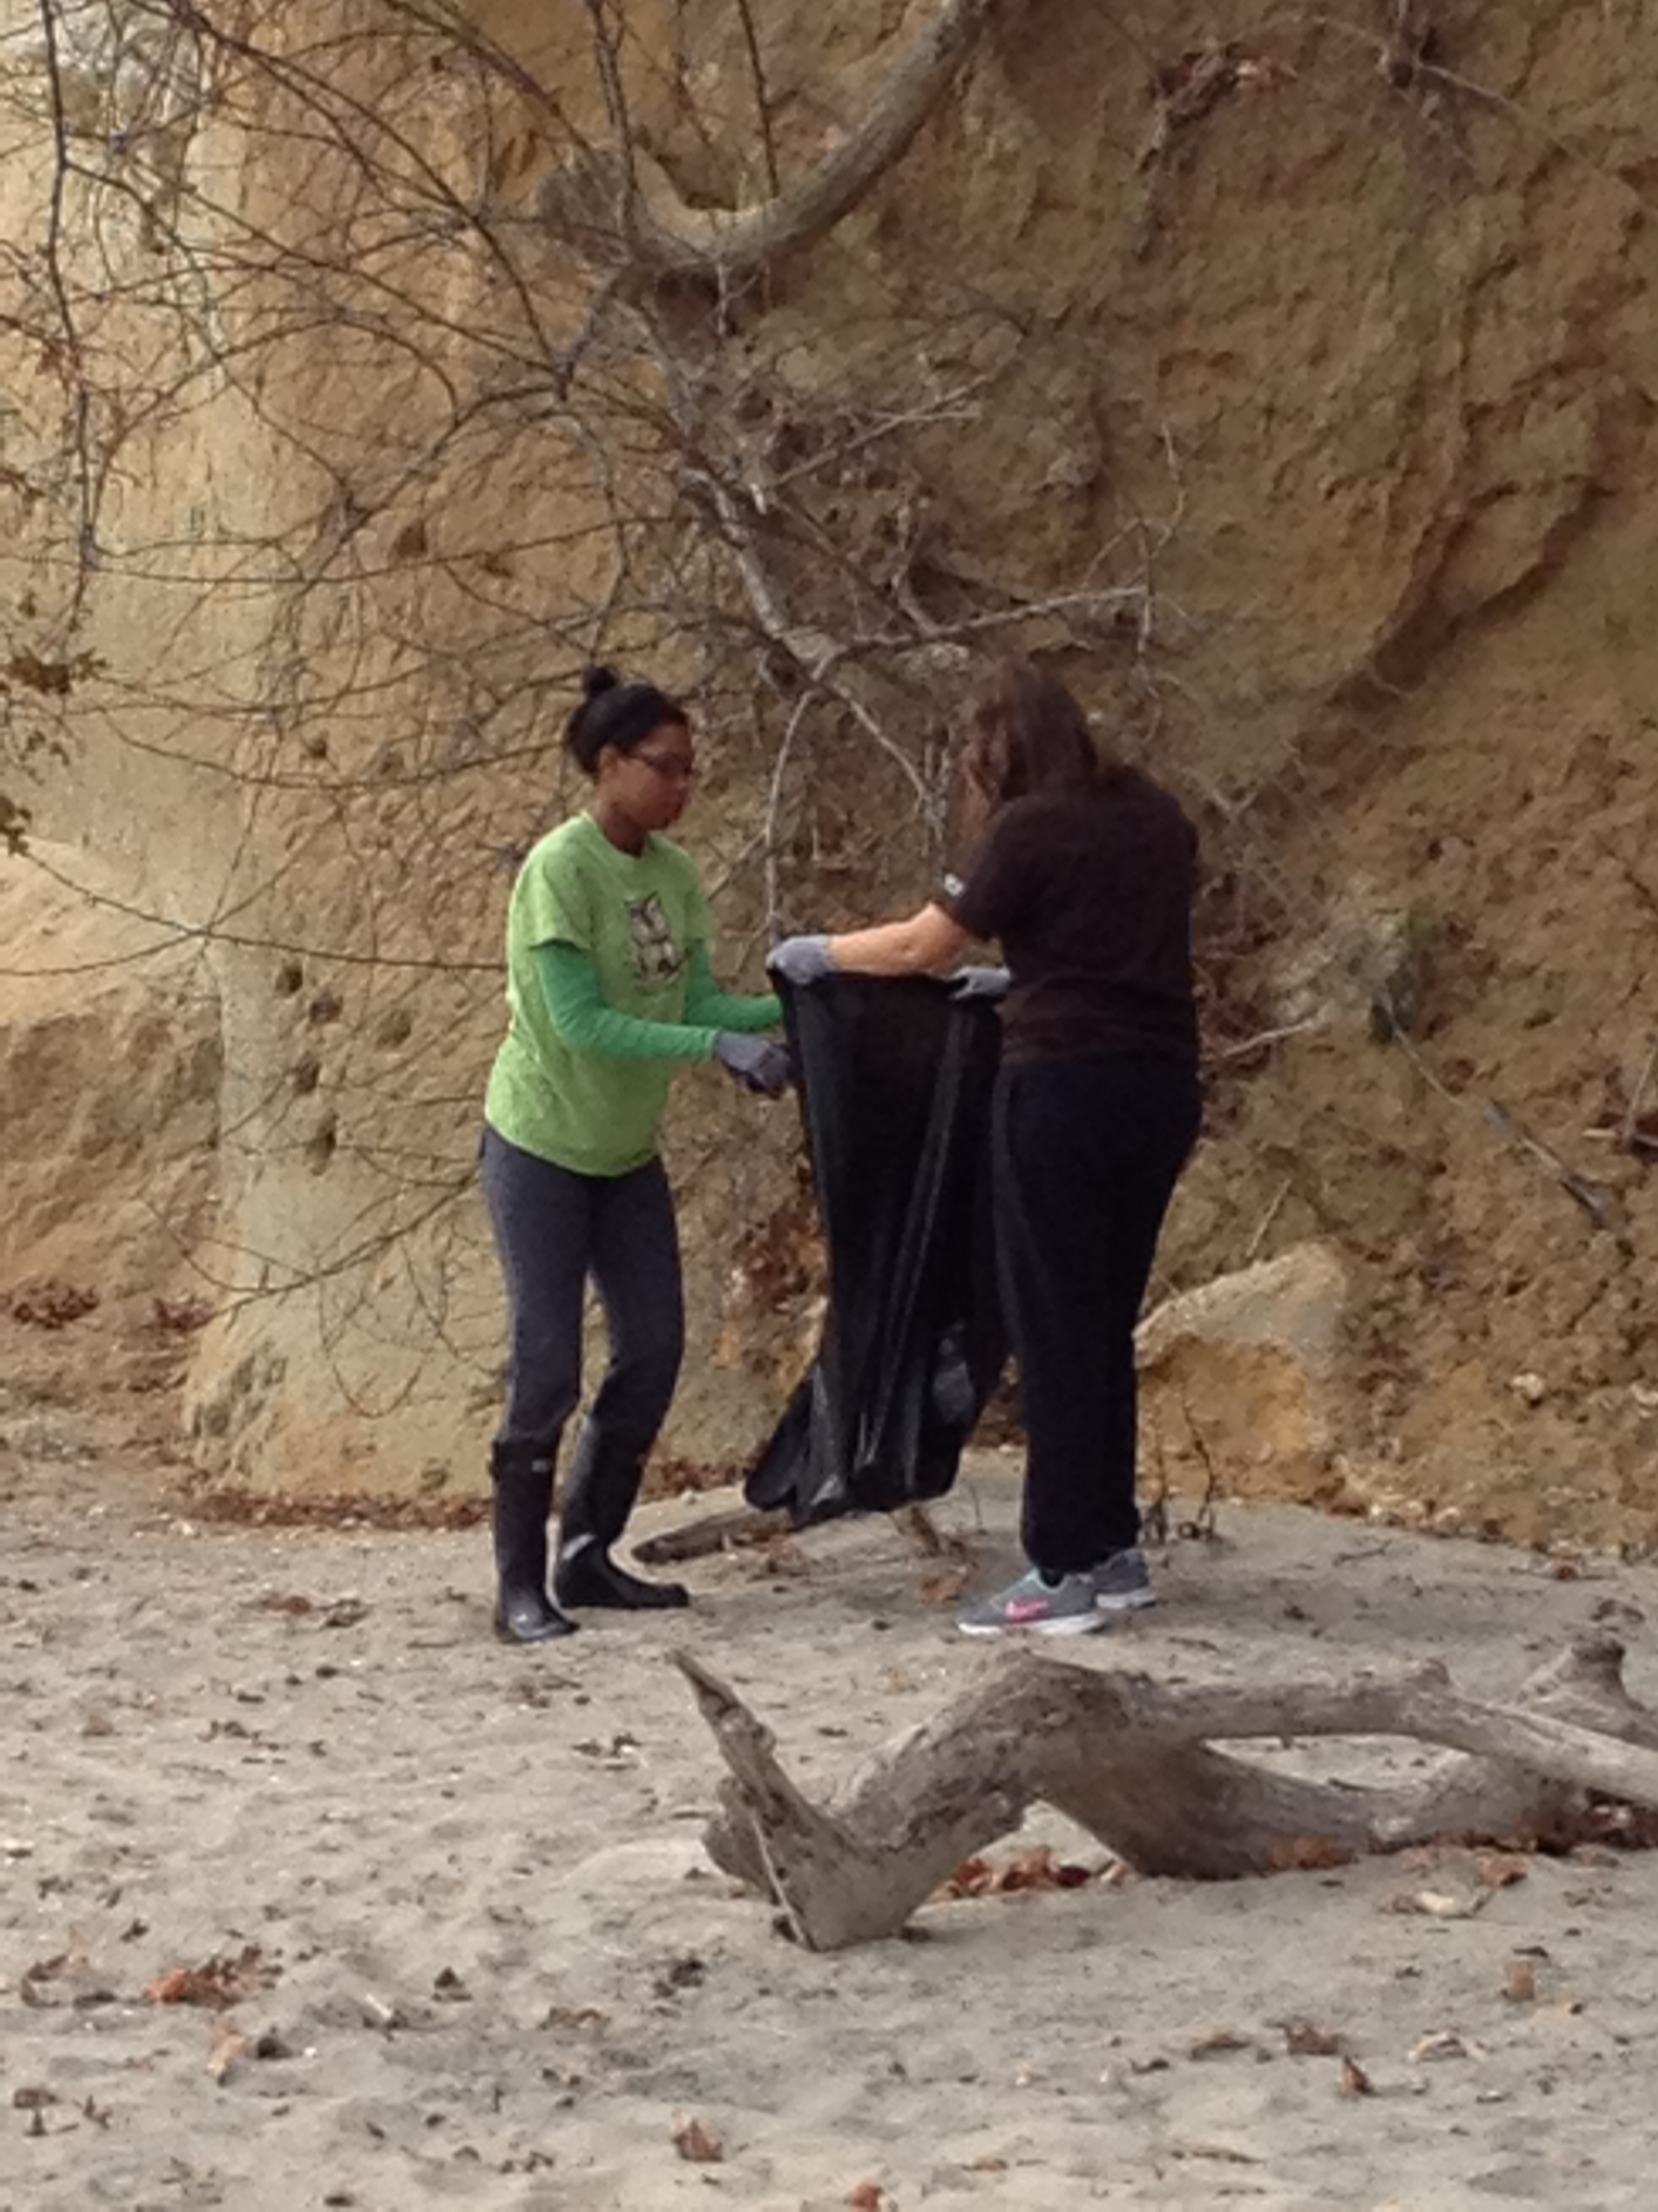 Students collecting trash at Bayside Park, October 24, 2015.

