2.1 Water Conservation/Pollution Prevention

Signage in school near fountains and faucets, in bathrooms.
Awareness signs are placed for viewing by entire school population, students and staff.
February 2016.

Water is not taken for granted at Northern High School. Housed in an old and failing building, we are often faced with less than crystal clear water coming from our facets, and recently a huge drain clog that made flushing the toilets a restricted activity. While the California drought was making headlines, it was decided that water awareness could be amplified by well-placed posters throughout the building.
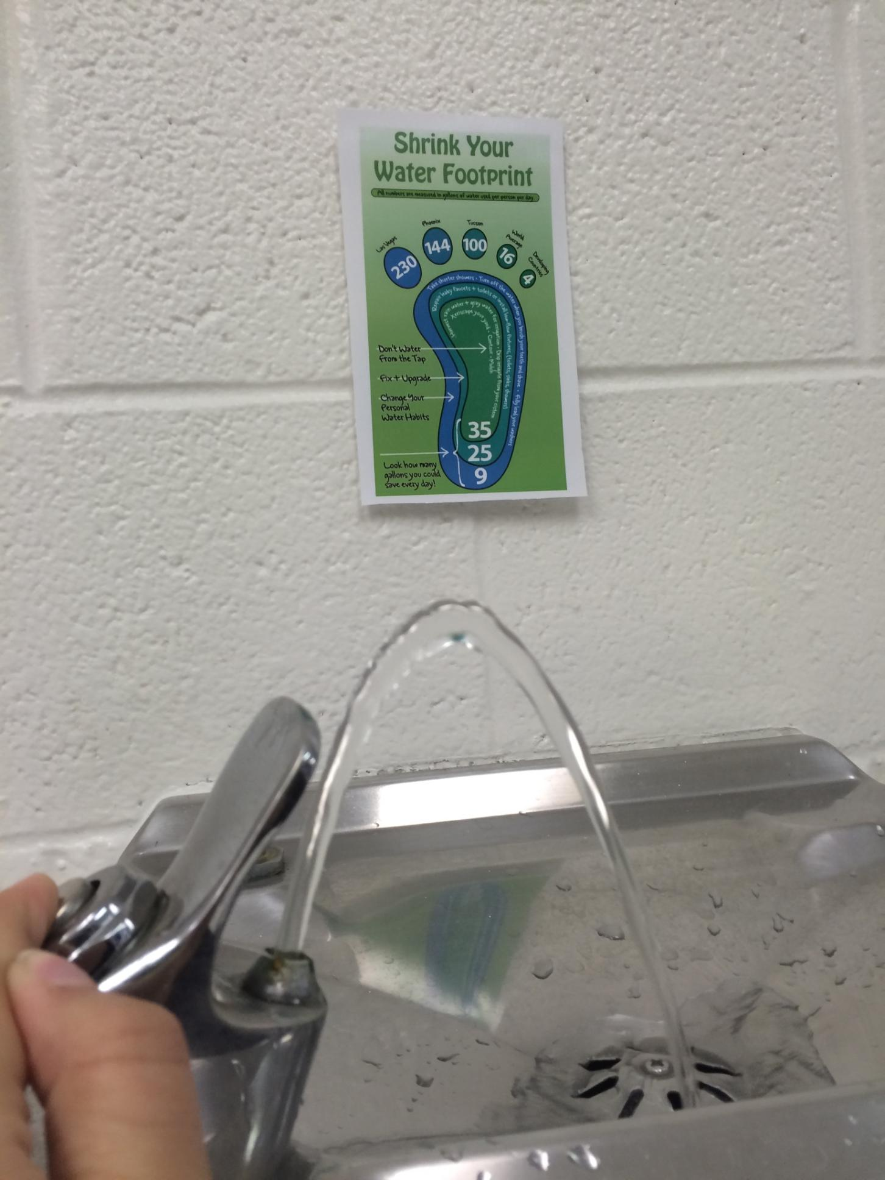
Posters were printed and tacked up by the Lorax club in areas where one might think about their water use; in sink areas, near water fountains, and in the restrooms. It is hoped that the water facts stimulate some thought about all the ways water is used in modern society.

