1.4 Celebration

Earth Week (April) 2012-2015

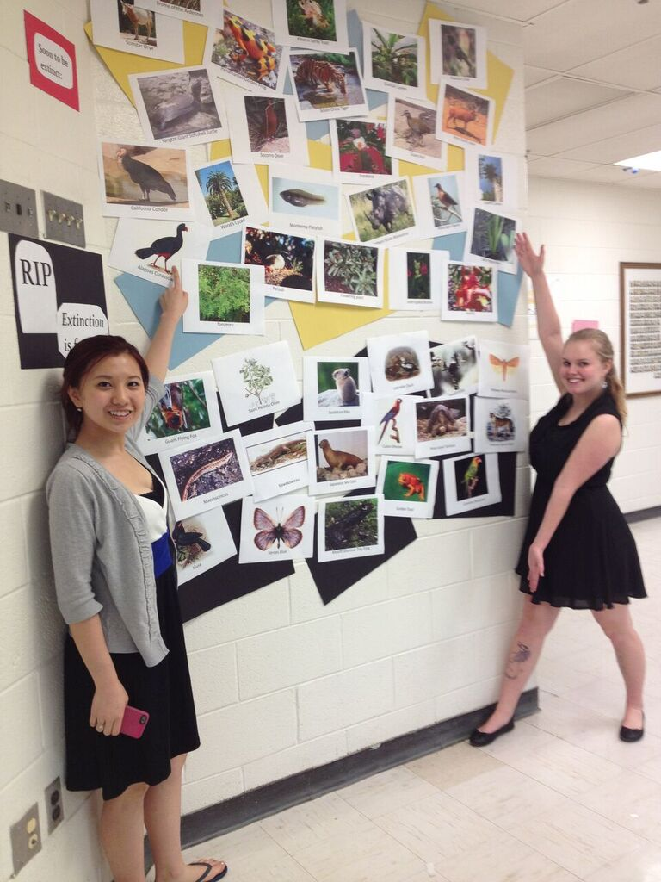
Each year for Earth Week, large displays are created that the school population will see. Bulletin boards in the hallways have displayed the history of Earth Day and a wall in the cafeteria was dedicated to endangered and extinct species. All displays have been followed up with school-wide announcements and posters that inform and provoke thought about the Earth Day theme for that year.

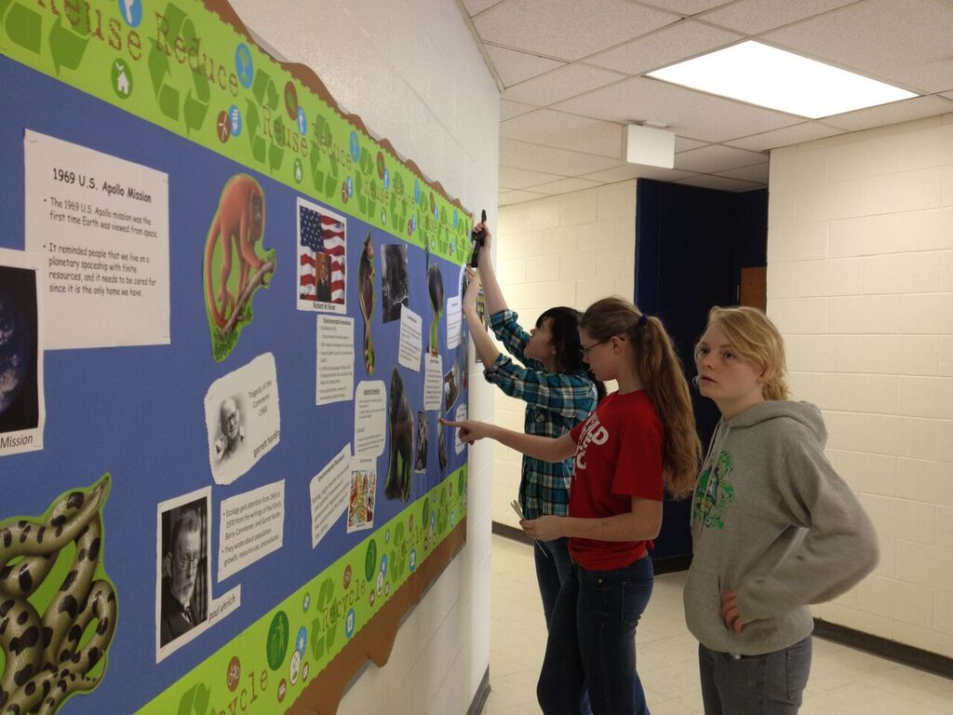
Lorax club members are proud of their displays in hallways and cafeteria.
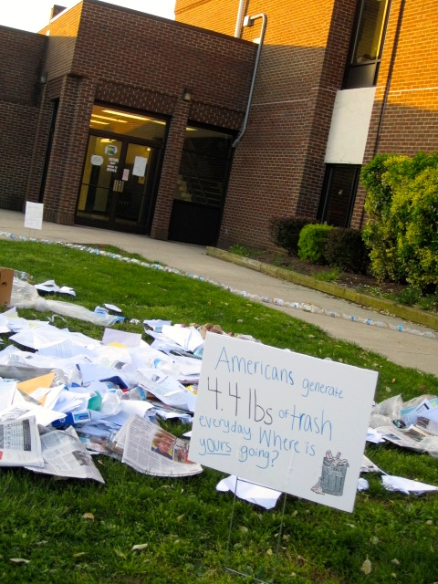
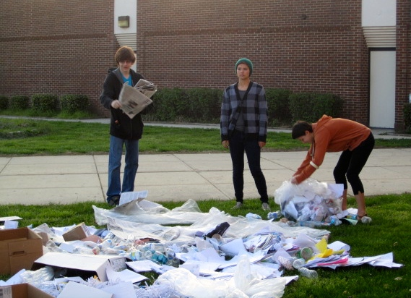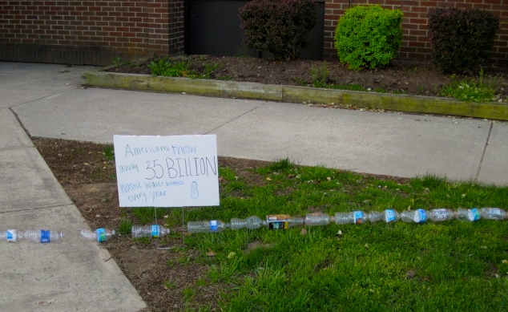
To provoke thought about how much waste Americans generate, Lorax members spread trash and post signs before buses arrive on Earth Day, 2015.
This display greeted NHS students as they got off the bus and entered the building that morning.

