1.3 School-wide Environmental Behavior Changes

A lot of conservation practices and other green behaviors have been put in place since the last certification of Northern High School.
- More areas of the building have been equipped with motion sensors so that lights are dimmed in rest rooms and hallways when they are not occupied.
- Teachers are encouraged to always use both sides of paper when making copies and both sides of the scan-tron sheet when giving quizzes. The daily bulletin to staff and the Weekly Blast to parents (which used to be a mailed monthly newsletter) are now completely digital.
- By using such platforms as Glogster, Blackboard, and edublog, many teachers have set up an online system for communicating assignments to, and taking written work from, their students. Mrs. Clites has been using a Moodle site since 2013 that allows her students to take both practice and graded quizzes, and submit homework online. (See screenshot below.)
- Calvert County doesn’t print report cards or interims anymore. All grade information is available to students and parents on the HAC (home access center).
- Several of the offices here have worked to reduce their electricity consumption by using task lamps. This has helped NHS reach energy conservation goals set by central office.
- Toner cartridges are routinely shipped back for recycling, and all cardboard shipping boxes that enter the building are recycled.
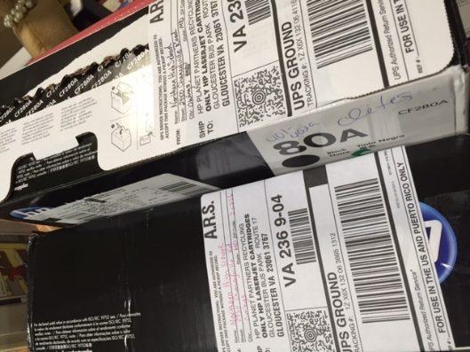

Mrs. Clites and Mrs. O’Donnell’s ink cartridges ready to ship out for recycling. Taken December 8, 2015.

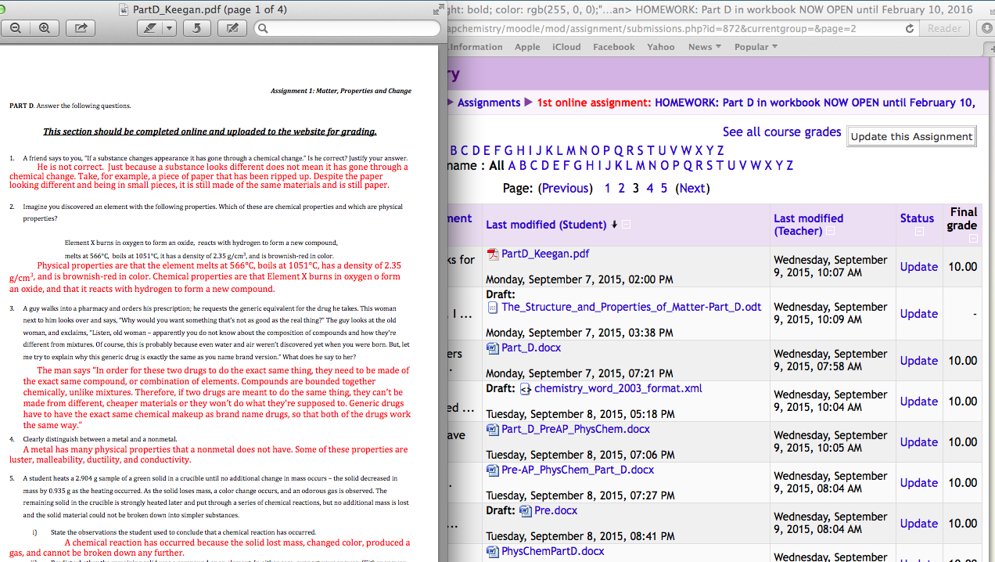
Screenshot of nhschemistry.org page showing how Mrs. Clites’ Pre-AP Chemistry students can submit homework digitally. September 2015.

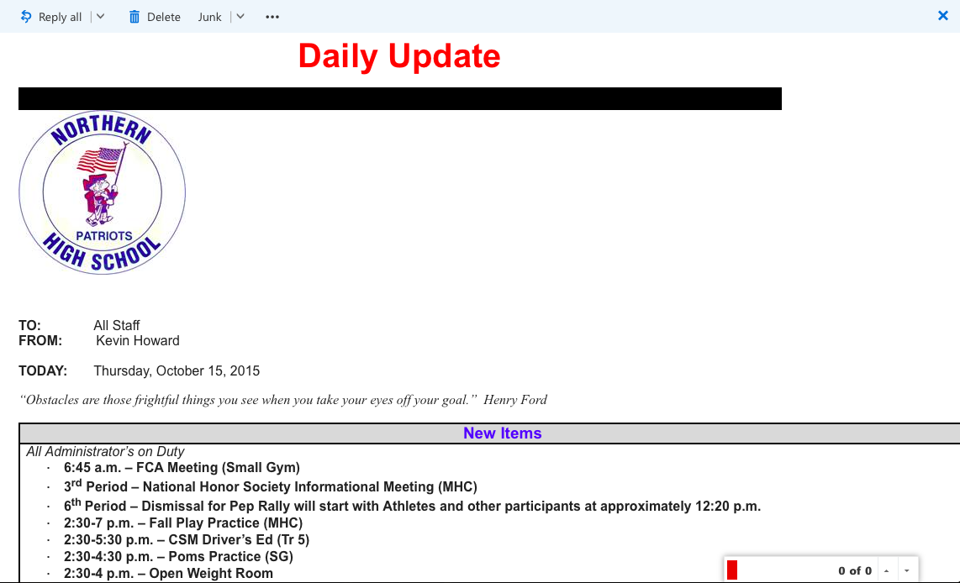
The daily bulletin keeps teachers updated without the need for paper.
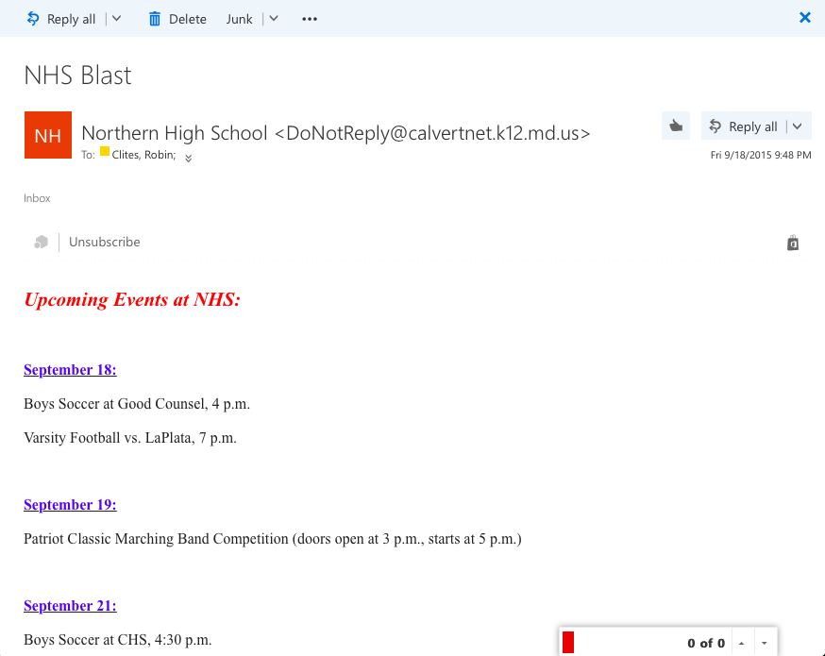
The weekly blast keeps parents informed without the need for paper.

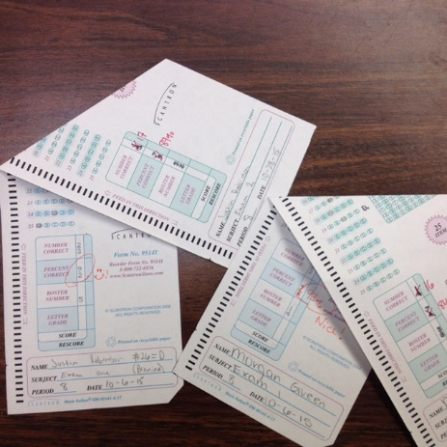
Most teachers use double sided bubble sheets to save paper.

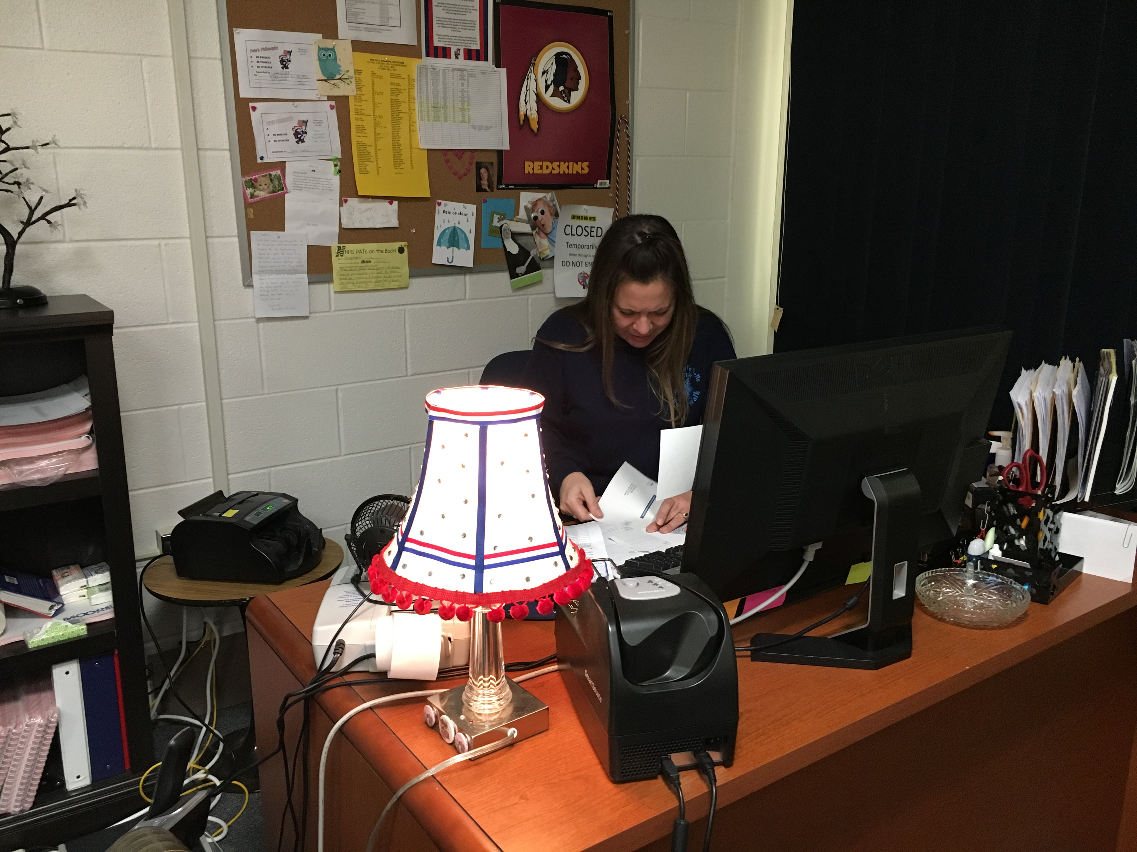
Ceiling lights in the financial office have actually been disabled and the staff there work with small task lamps only, conserving electricity every day.

