POW! The planning of Wetlands
7.5 hour course on June 30, 2015 at Calvert High School
Environmental Concern ran this course for teachers this past summer. They are helping us try to create an outdoor learning environment at each of the 4 high schools so that we can take our students to complete the “Meaningful watershed experience” all high school students need to have.

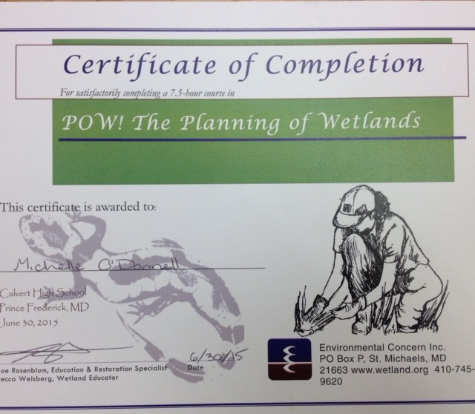
Integrating Schoolyard Habitats into Your Curriculum
6.5 hour course on September 17, 2015 at the CCPS board of ed.
Environmental Concern ran this course for 5 of our teachers. This course was given to us so that we can incorporate more lessons in our curriculum to prepare our students for their “Meaningful Watershed Experience”. Michelle O’Donnell, Krystal Butler, Lisa Lacey, Andrea Doyle and Michael Hitchman attended.

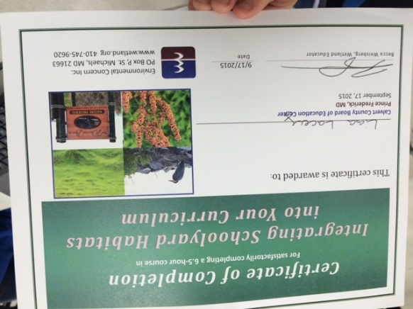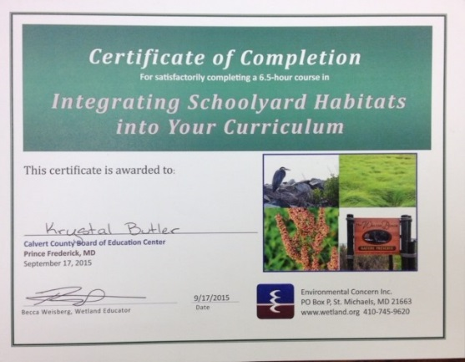
Lisa Lacey Krystal Butler

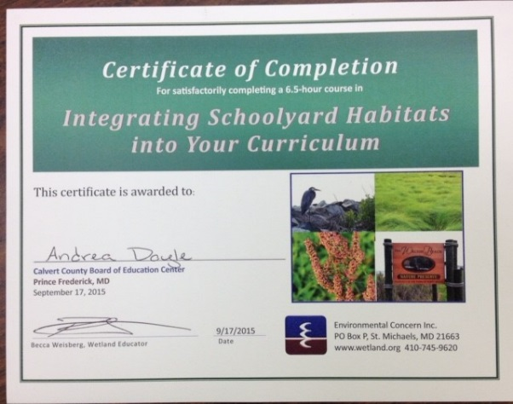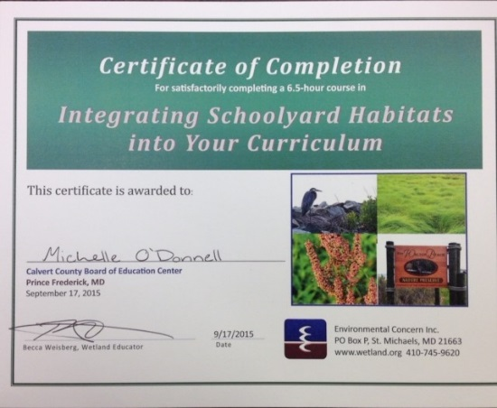

Andrea Doyle Michelle O’Donnell

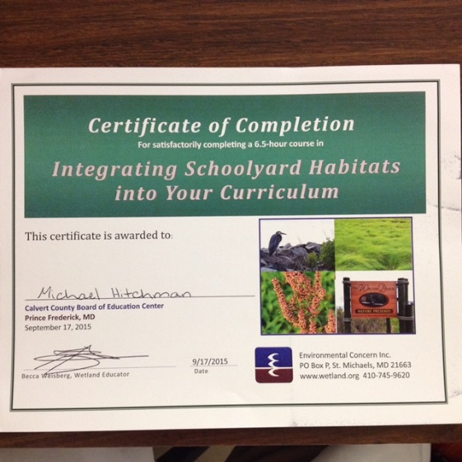
Mike Hitchman

