1.2 Professional Development/Environmental Training
NHS teachers have attended classes that are part of the University of Maryland Extension program.

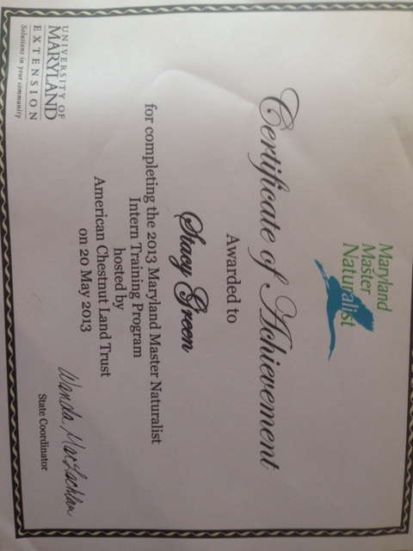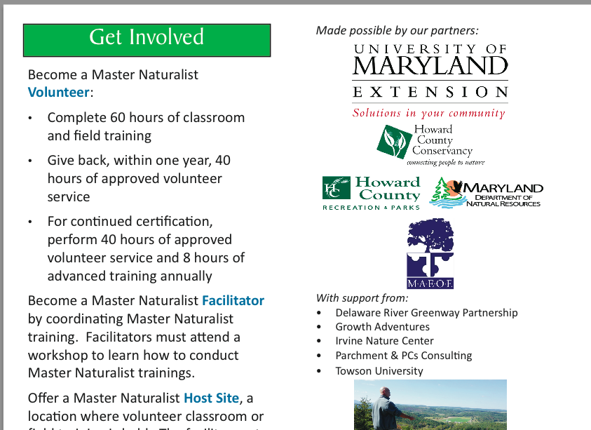

Stacy Green, Environmental science and Earth Science teacher, completed a 60-hr course through the University of Maryland to become a Maryland Master Naturalist. Certificate received on May 20, 2013.

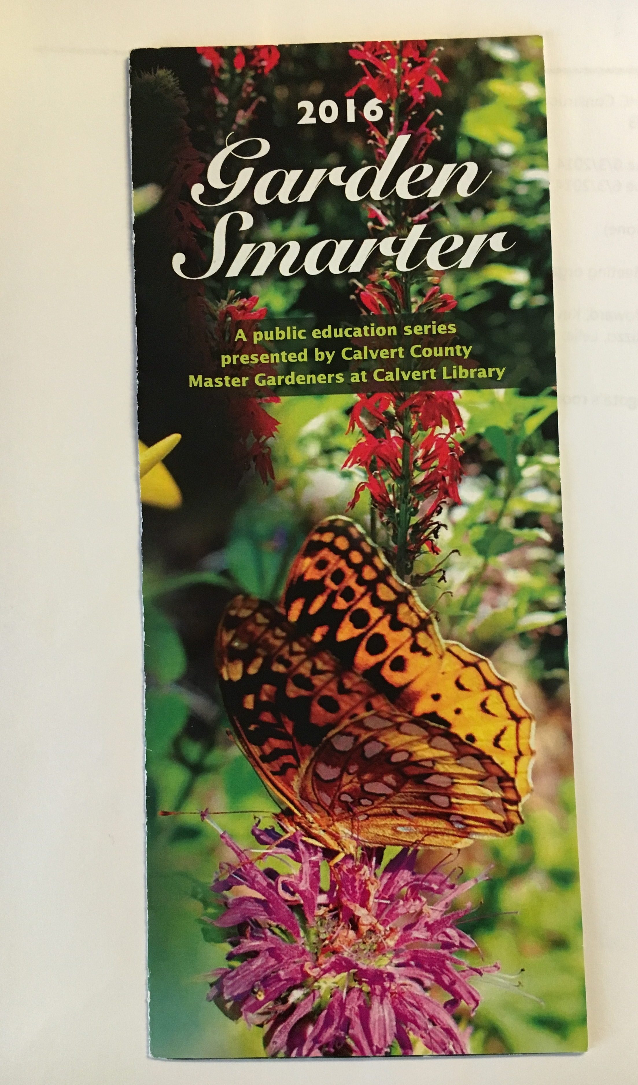
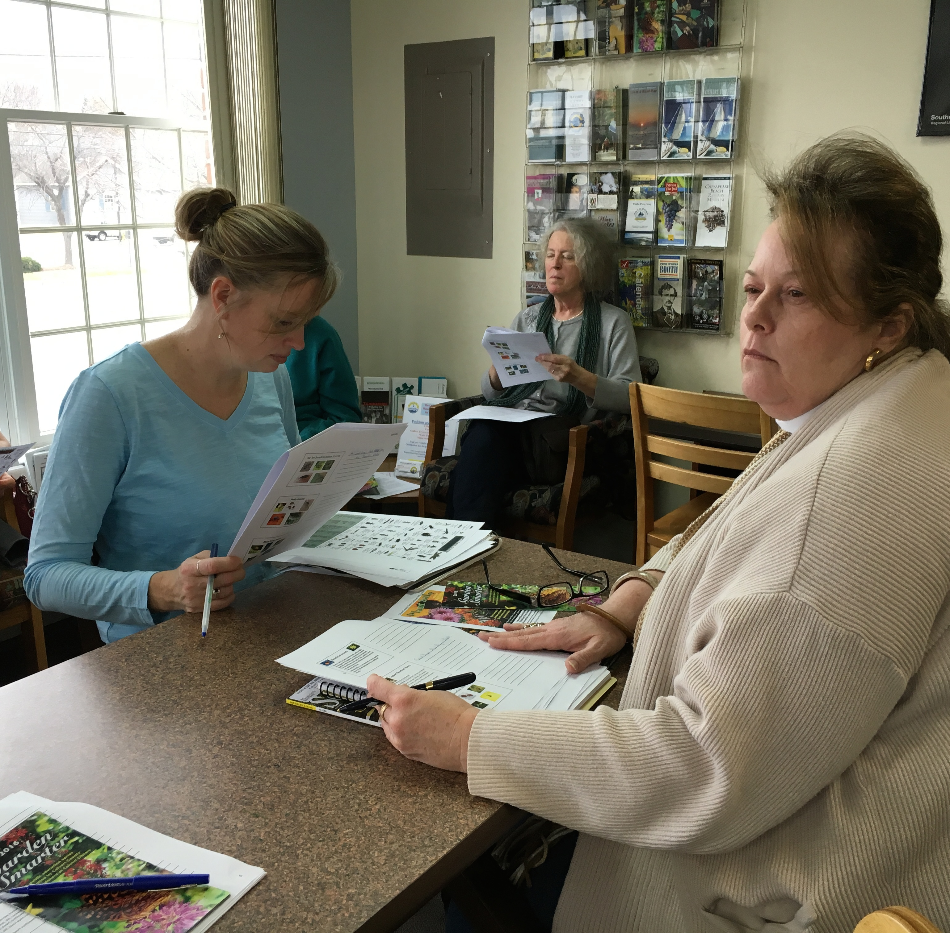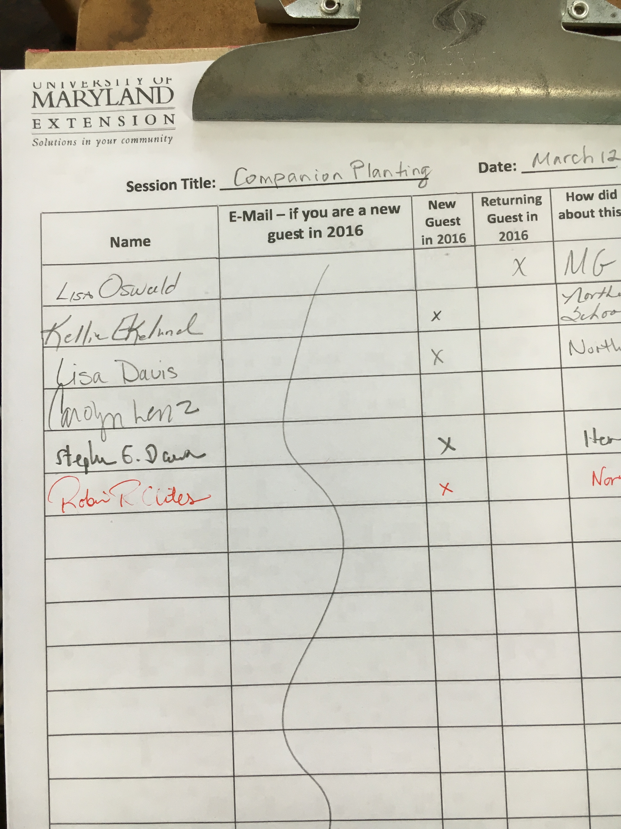
Kellie Ekelund, Lisa Davis, and Robin Clites have attended sessions given by the Master Gardeners of Calvert County. Their names are on page 2 of the sign-in sheet for March 12, 2016.

