1.2 Professional Development/Environmental Training
In order to participate in developing a document required for LEED Silver certification, the staff at NHS had learn a lot about green design. Environmental science teachers, Principal Kevin Howard, and Mr. George Leah (director of school construction for Calvert County) gave several presentations to the staff over three years to prepare them for the building of this new, unique school. Some presentations were during inservice days, some during after school meetings. What is LEED certification; what features are required in a building to make it LEED silver certified; and how can teachers use those building features to deliver lessons on sustainability, were all topics discussed. The awareness of the staff grew tremendously through these presentations.

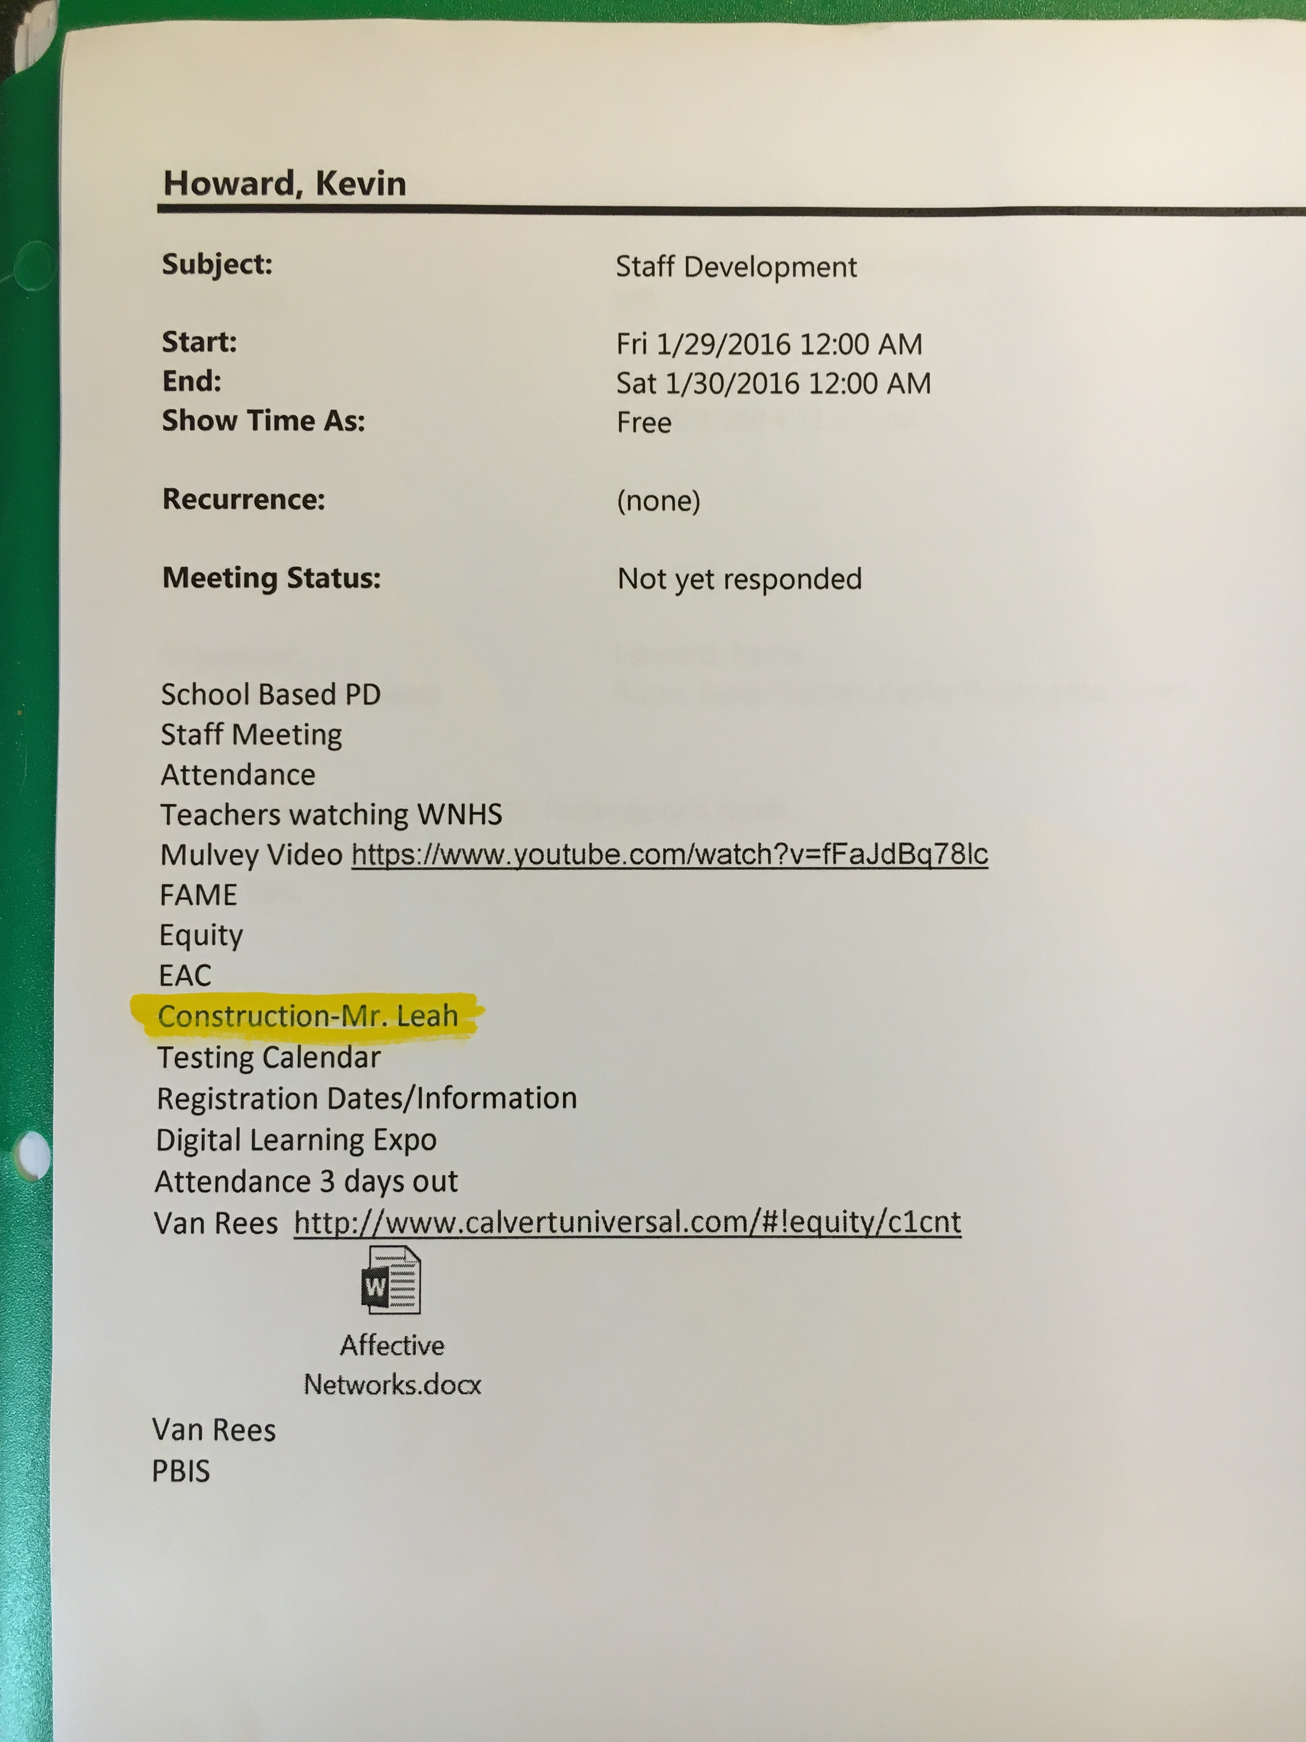
Principal Howard’s latest calendar item showing Mr. Leah’s visit to the school to discuss news on the LEED building construction. In this meeting we learned that all the green features would be kept, but the school would be downsized in order to meet budget requirements.
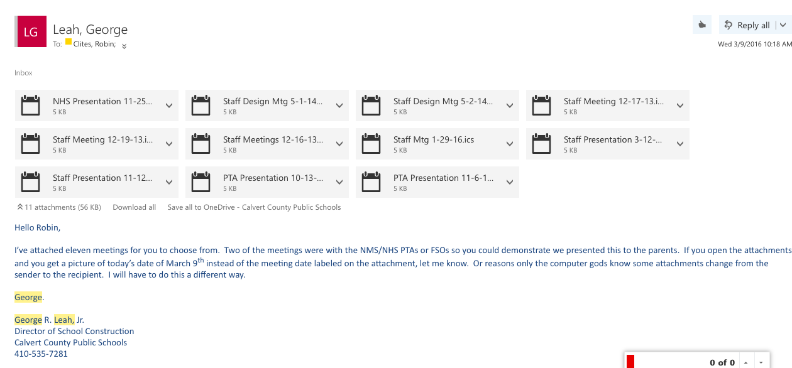
Mr. Leah’s calendar appointments with Northern High and nearby Northern Middle School showing the many visits he made here for presentation of LEED certification and building features the staff needed to be familiar with.

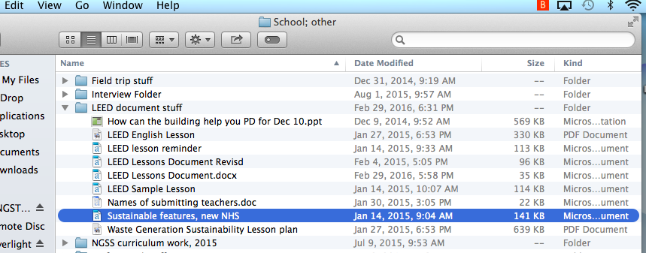

Mrs. Robin Clites was lead teacher on the document required for LEED certification that NHS constructed. This screenshot of Mrs. Clites computer file shows a PowerPoint designed and presented at December 2014 staff development session, and that features of the building were clarified with staff in January 2015. From January 2015 – February 2016, staff contributed to the LEED document for a final revision submitted in March 2016.

