Fall 2014/spring 2015/Fall 2015
Walton Beach nature preserve shoreline and wetland overlook park in north beach.
9th and 10th grade
300 Biology students
Michelle O’Donnell, Lisa Lacey, Cathy Dangin, Krystal Butler, Andrea Doyle, and Michael Hitchman’s classes.

To meet the “Meaningful watershed Experience” requirement for Environmental Literacy Environmental Concern planned 2 half day field trips to Walton Beach Reserve in North Beach. North Beach received a grant to make a living shoreline on Walton’s Beach where erosion has been washing away the shoreline there for years.
Students participated in 4 stations on the beach and then 3 stations at the North Beach overlook across the road. Some of the activities they did:
-Using Sein net to catch animals
-soil testing
-water quality testing
-food chain/predator/prey activity
-planting sea grasses
-looking for signs of wildlife
-surveying
Environmental concern also did one day of lessons at our school. Students:
-made awareness posters
-invasive species

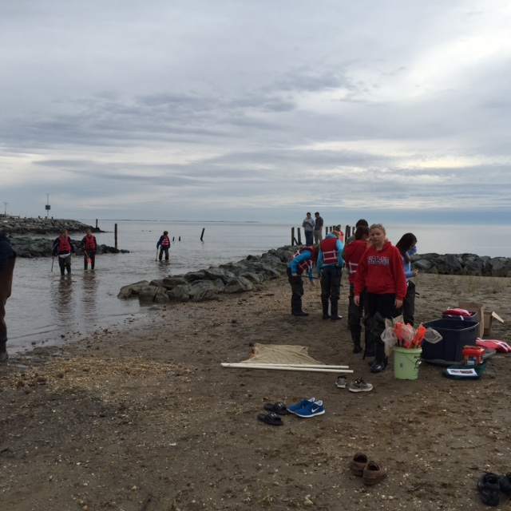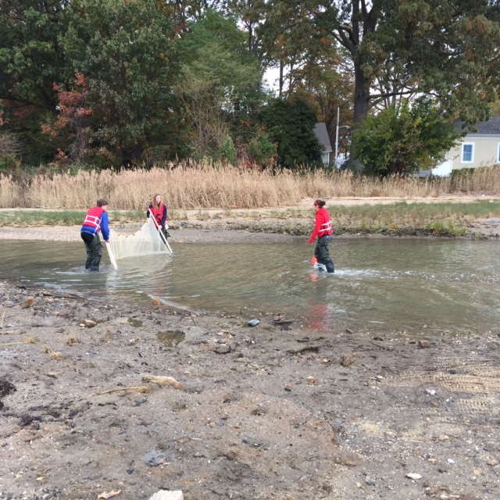
Biology students at the Wildlife station on Nov. 2, 2015.

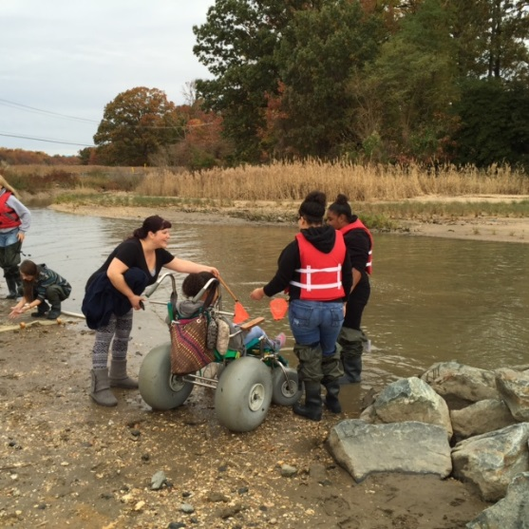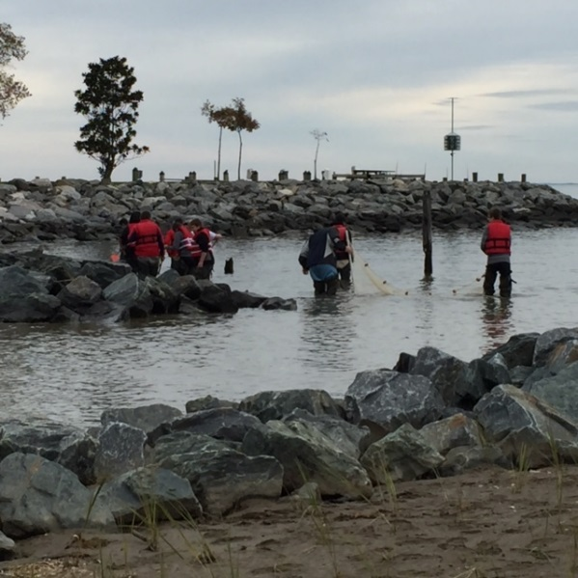
Biology students using the sein net at Walton Beach, Nov. 2, 2015

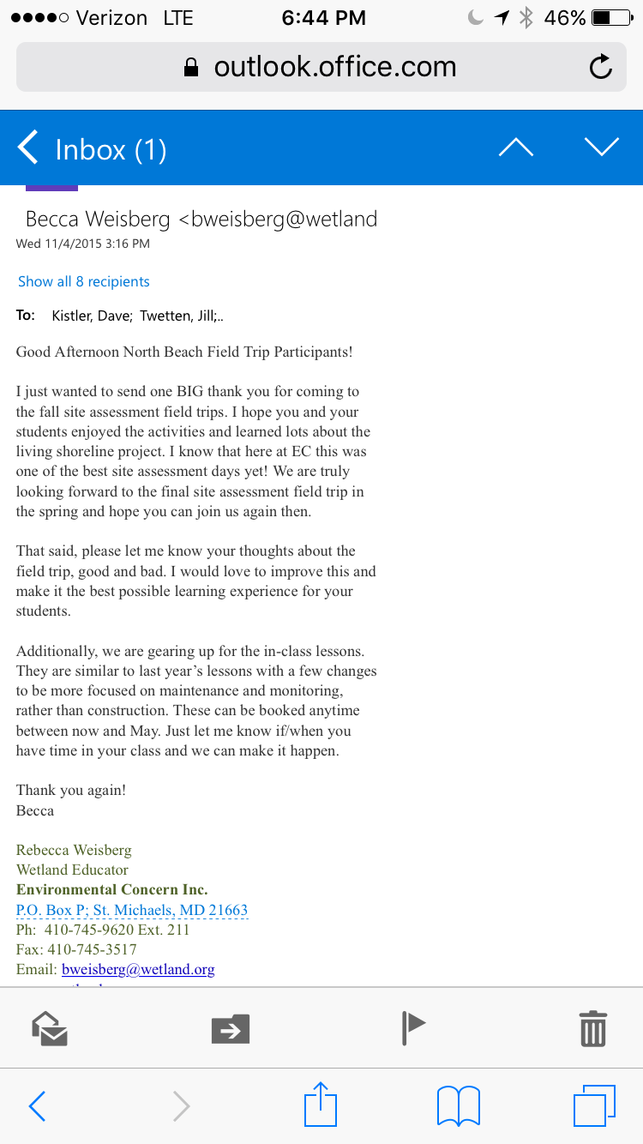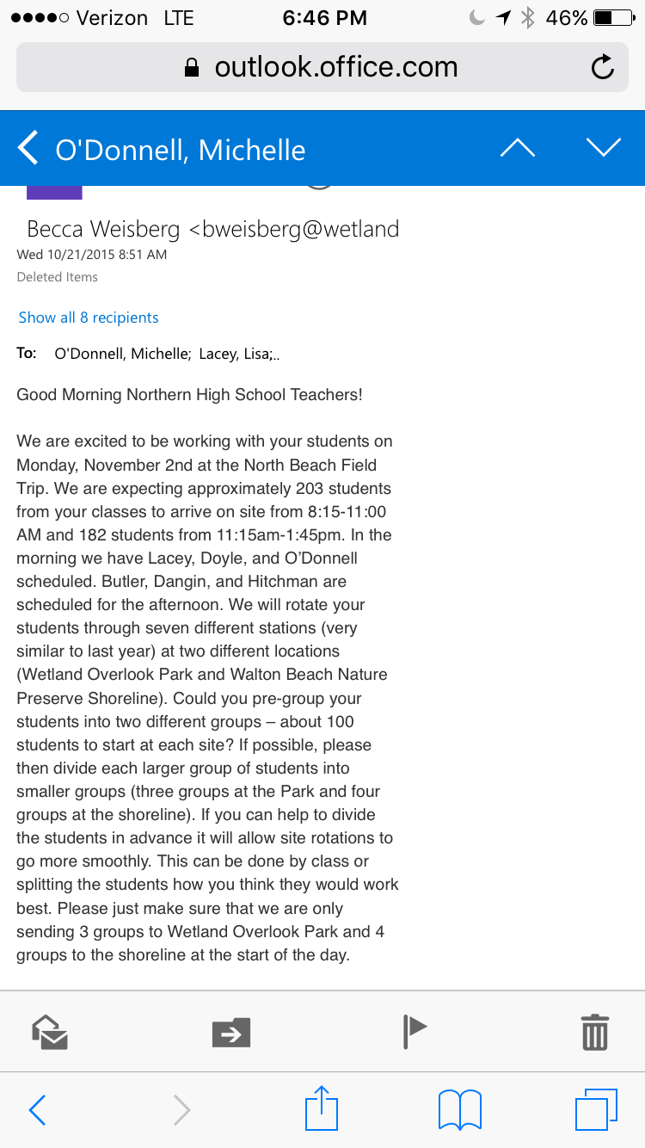
2 emails this year coordinating the trips and then getting feedback from the trip so they can discuss things when they come in the spring for in the in class lessons.

