**Objective 1 Systemic Sustainability**

**1.1 Environmental issues curriculum**

**Sociology lesson on values, norms, and sanctions that shape recycling efforts in the United States.**

**Grades 11 and 12, all sociology classes; (125+ students). Lesson is permanent part of the curriculum; used every year.**

Students in Ms. Kat Down’s sociology class study how values, norms and sanctions shape behavior. One of the ways they are prompted to apply this concept is to explore recycling efforts in the United States. Interesting discussions and visuals are always the result.

KINGSTON:Green School 2016:Recycling Values Norms Sanctions.pdf

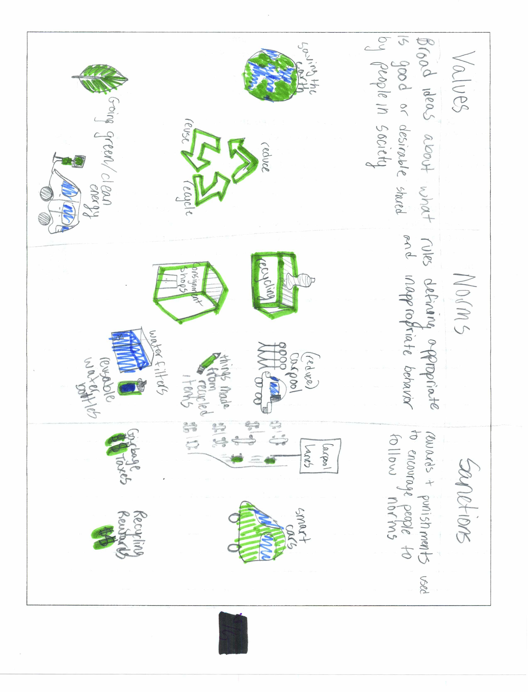 Student work attached is from current (2015-2016) school year.