**1.1 Curriculum & Instruction: Environmental Issue Instruction**

**Ms. Bonalewicz’s AP Spanish class; assignment comparing the USA (or our community) to a specific Hispanic country in terms of environmental awareness and cultural values.**

**20 students each year, 2014 – 2015, Grades 10-12.**

Students were asked to design and construct a PowerPoint comparing environmental issues and values in their own country/community with those of a Hispanic country. PowerPoints were then presented and discussed in the class.

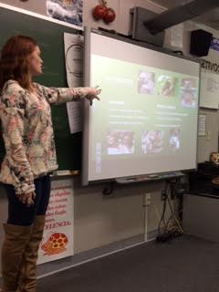

Senior Meghan Klink presenting her PowerPoint, November 2015

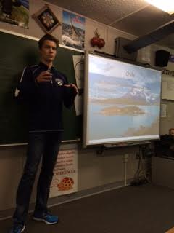

Senior Michael Williams presenting his PowerPoint, November 2015

Macintosh HD:Users:rclites:Desktop:Presentación Ambiental.pdf

Original assignment given to AP Spanish students

Link to student work (PowerPoint designed by junior Jennifer Cole:

https://docs.google.com/presentation/d/1d2wKpAO4ATeQGLWJSX-hEDVn4_evE12YkrdtdZliXEA/edit?invite=CKyt96YO&ts=56b10d2d#slide=id.p