Objective 1 Systemic Sustainability
1.1 Environmental issues curriculum

Greenhouse construction on NHS campus by Technology Education students

Grades 9 – 12, all technology education classes involved; (120+ students) with focus groups doing the construction (25 students).
Project began in Fall 2015. Greenhouse is planned for completion in April 2016, and expected to be in use for the next several school years.

To compete for a grant, Mr. Cranford’s six technology education classes were asked to propose a project to address one of the most pressing concerns in our community. One of their proposals focused on the problem of hunger and lack of fresh, local organic foods to meet that need. Although students did not win the grant (only two were awarded in Maryland) our Principal thought that this project should to be funded. Provided with $1000 and a donation of lumber by the nearby hardware store (Sneade’s Ace Hardware) Mr. Cranford’s classes began designing and building a greenhouse. This structure -complete with a rain barrel watering system - will be used by different groups in the school for growing edible plants. It is hoped that the harvest will be plentiful enough to be donated to local food pantries on a regular basis.

Future technology students will work to add a solar or wind–powered pump to get the water from rain barrels throughout the greenhouse.

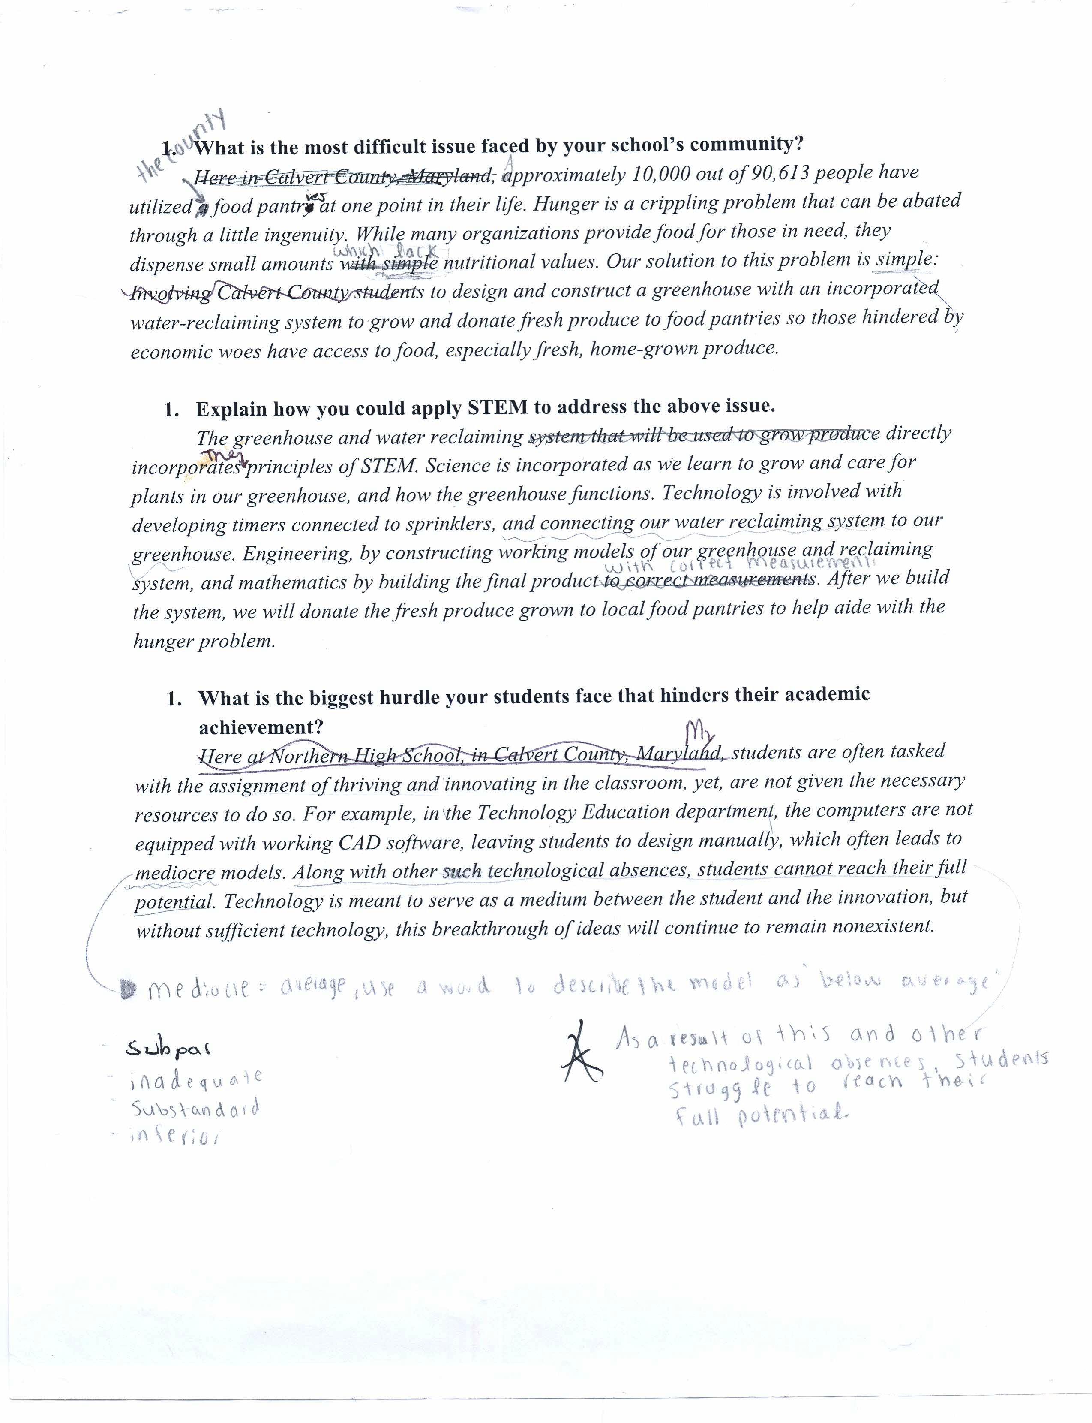
Student work on original assignment: Draft version of student essay proposing the design and construction of a greenhouse and water reclamation system for growing and donating vegetables.

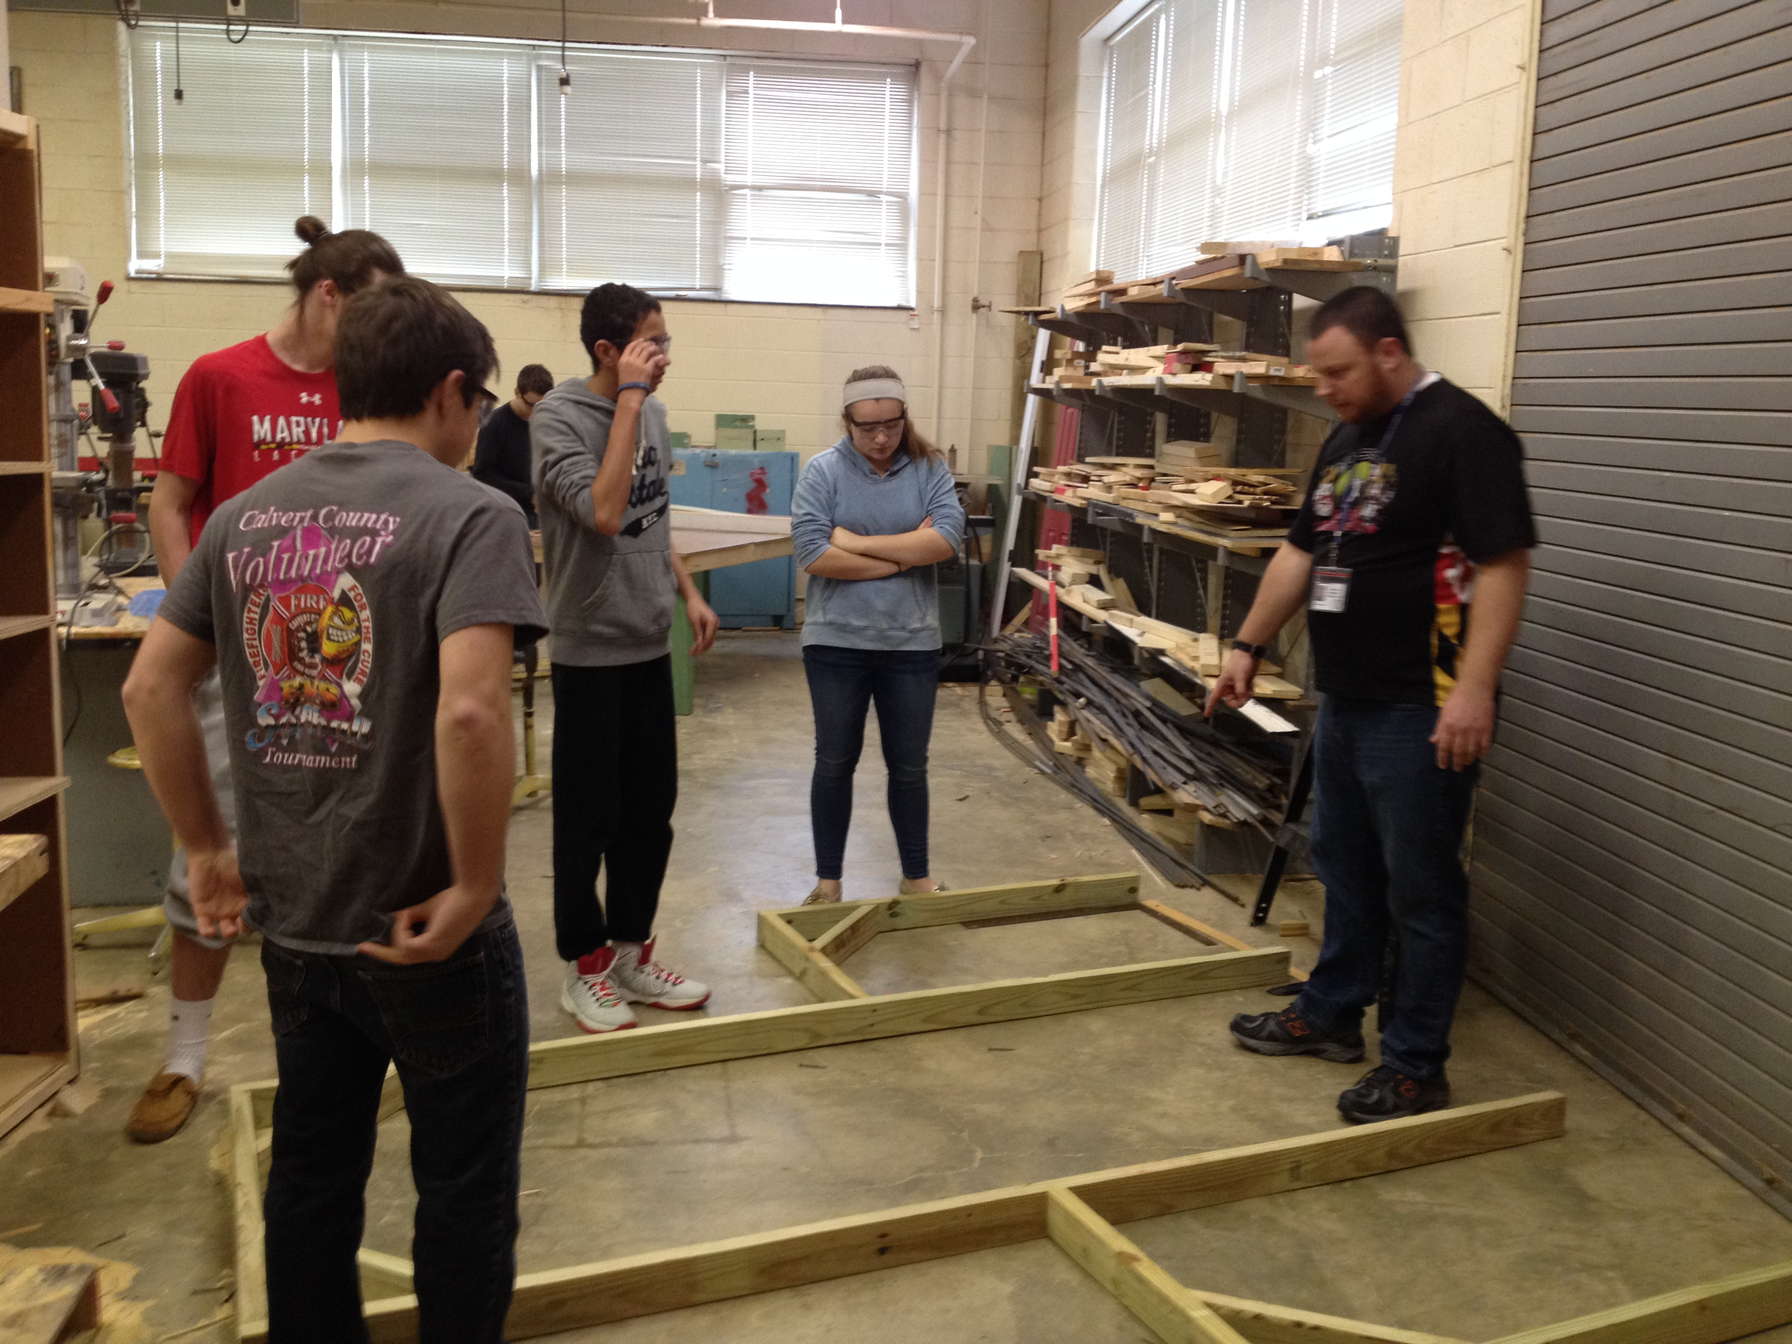
Mr. Cranford and tech-ed students discussing how the wooden frame should be braced.
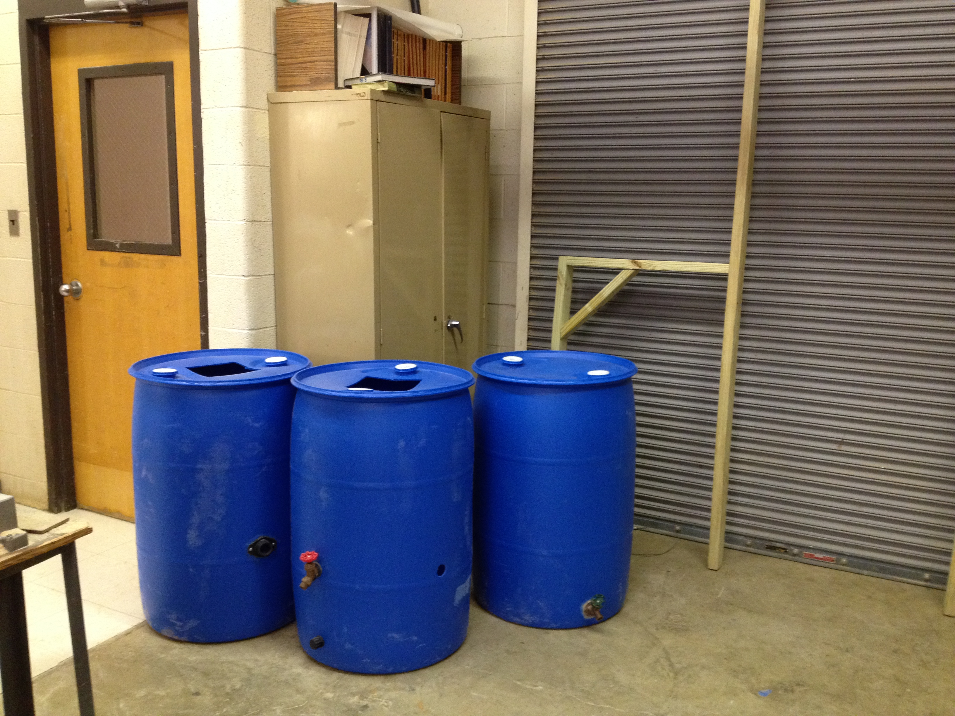 Rain collection barrels to be used as part of the greenhouse irrigation system.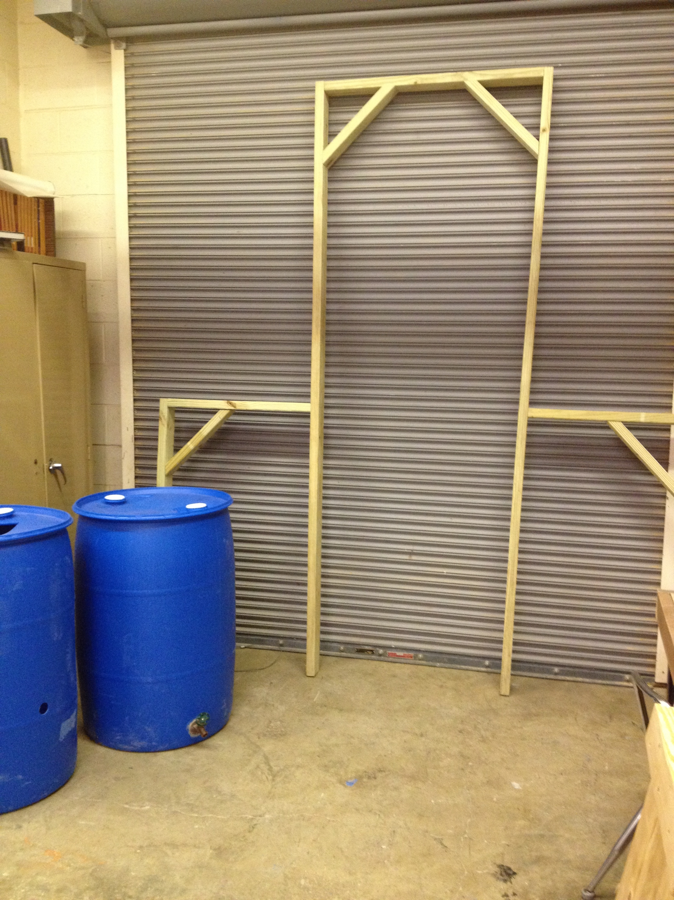
One frame of the greenhouse, completed and awaiting final assembly.

